Edexcel A Level Music

“Learning through arts and culture improves attainment in all subjects” and the “employability of students who study arts subjects is higher and they are more likely to stay in employment.”
Cultural Alliance

Course Content/Units
- Component 1: Performing
- Component 2: Composing
- Component 3: Appraising

This qualification is a fantastic opportunity to learn, develop and demonstrate musical skills and techniques. Students will learn composition, performance and appraising, over a range of musical styles: Vocal Music, Instrumental Music, Music for Film, Popular Music and Jazz, Fusions, and New Directions.

Course delivery:
- You will have a third more teaching time studying any of your courses at Abbeyfield Sixth Form.
- Results are consistently strong. Students achieved 100% A*-C in 6th form Music in the last two cohorts.
- Class sizes are small and we get to know students’ strengths and areas for development quickly.

Progression:
Music graduates have a wide range of career options available to them both inside and outside the industry, including: performer, teacher, music therapist, administrator, and songwriter, composer, recording engineer, manager, promoter or music publisher.

However you are not limited to the field of music! It is very common to find music graduates in consultancy, finance, banking and legal jobs.

Minimum Recommended Entry Requirements:
- English Grade 4
- ABRSM or equivalent practical exam
- Optional: Music Grade 6 studied at GCSE

What do the students say?

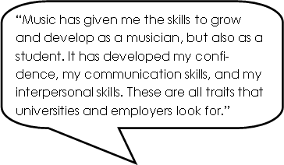

CONTACT:

- Mr Alistair Jennings - aoj@abbeyfield.wilts.sch.uk
- Mrs Zoe Young - zey@abbeyfield.wilts.sch.uk

