Religion, Philosophy and Ethics OCR (H573)

Do you enjoy asking questions? Debating issues? Accepting there may be no right answer? Do you want to understanding why people believe what they do and how it might make them behave? Then Religion, Philosophy and Ethics is the course for you!

Course Structure: The A level exam is made up of three courses:

Philosophy of Religion considers some big questions of human existence. Why are we here? What does it mean to be a human? Is there a God? What happens when we die? Can we resolve the problem of evil and suffering? We consider these questions alongside the study of how thinkers over time have responded to them, and consider what makes a sound argument. The course covers thinkers from the beginning of Philosophy with Plato and Aristotle to modern day thinkers like John Hick and Richard Dawkins.
Ethics is all around us. Questions and dilemmas challenge us all the time in our relationships, at home, school or in society.. Ethical questions include how do we make moral decisions about right and wrong? Do I have a conscience? Or freewill? Can I apply ethical ideas to issues surrounding abortion, euthanasia and genetic engineering? In this course you will consider how people make moral decisions over a wide range of issues such as medicine, sexuality and business.
Developments in Religious Thought allows students to study Christianity in greater depth and focuses on how key beliefs and practices have developed over time. The course also explores the place of religion in the modern world considering its impact on law and society. Questions asked by this course include why do people believe what they do? What sources of authority do Christians use and how reliable are they?
Course delivery: Lessons are a mixture of discussion, small group work and lecture style learning. Students will be asked to give presentations, research ideas, develop their skills in structured discussion and analysis of arguments.

Assessment:
Unit 1 (H573/01) | Philosophy of Religion  Two hour written paper. Students answer 3 essay questions from a choice of 4
Unit 2 (H573/02) | Ethics  Two hour written exam. Students answer 3 essay questions from a choice of 4
Unit 3  (H573/0) | Developments in Religious Thought  Two hour written exam. Students answer 3 essay questions from a choice of 4

Resources:
It is recommended that students buy one of the following books:
- Oxford A Level religious studies for OCR AS and Year 1 – Libby Ahluwalia and Robert Bowie
- Religious Studies for A level year 1 and AS (Hodder) – Michael Wilkinson and Michael Wilcockson

Progression:
Religion, Philosophy and Ethics is highly regarded by universities as it develops key skills in debating, discussion, research and analysis needed for many courses and careers. It particularly suits students considering studying Law, Philosophy, Theology, History, English, Psychology and other essay based subjects. It goes particularly well with English, History, Law, Psychology, Sociology, Art and Performing Arts.

Minimum Recommended Entry Requirements:
5 at GCSE Religion, Philosophy and Ethics (if taken) and 5 in GCSE English. Students with a 4 may be considered if they have a clear interest in the subject and good essay writing skills.

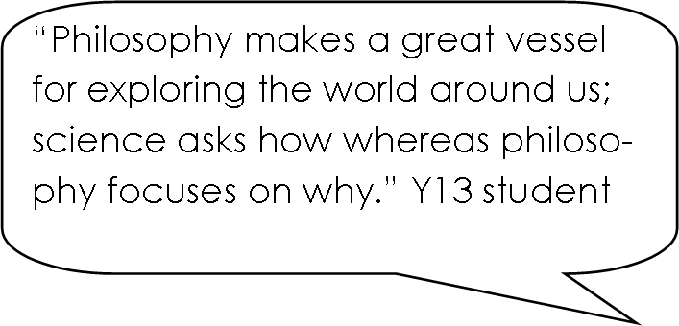
What do the students say

