English Literature AQA 7712

Do you have a love of reading? Are you fascinated by wide ranges of literature in different genres? Did you enjoy linking the literature you studied at KS4 to the contexts in which they were written? The new English Literature course is varied and accessible, suiting those with open and enquiring minds.

Course Structure: The two year course, culminating in A level exam is made up of three modules:

Love Through The Ages
In Love through the ages, the theme of love, one of the most central themes in literature, is explored across time. Given the spirit of the specification, rather than imposing a uniform list of prescribed set texts, various options are offered in terms of both time period and genre. The texts on offer range from the more traditional, such as Shakespeare’s Othello and the Romantic poets, to more modern texts like The Great Gatsby and Rebecca
Independent critical study: texts across time
In Texts across time, students write a comparative critical study of two texts. This particular module allows personal reading choices and Texts across time provides a challenging and wide-ranging opportunity for independent study. Possible themes for the comparison are chosen by students who are free to develop their own interests from their own wider and independent reading.
Modern times: literature from 1945 to the present day
A broad ranging choice of texts exploring issues faced in modern times to include social identity; changing morality and social structures; gender, class, race and ethnicity; political upheaval and change; resistance and rebellion; imperialism, post-imperialism and nationalism; engagement with the social, political, personal and literary issues which have helped to shape the latter half of the 20th century and the early decades of the 21st century.
Set texts include Atwood’s the Handmaid’s Tale and Williams’ A Streetcar Named Desire, as well as a body of poetry by Carol Ann Duffy
Course delivery: Lessons are a mixture of discussion, small group work and taught sessions. Students will be asked to give presentations, research ideas, develop their ability to synthesise and develop an argument and to write clearly and expertly. Wider reading will be encouraged to allow students to develop a confident command of how contexts influence literature, so independence and energy is required.

Assessment:
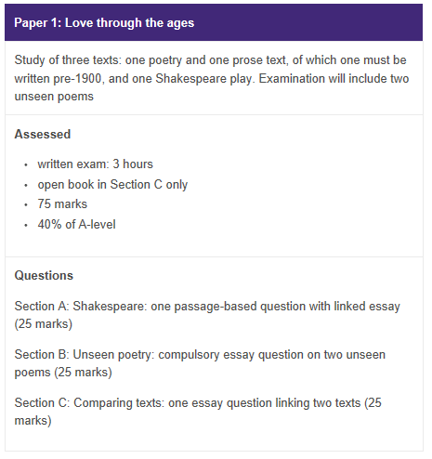

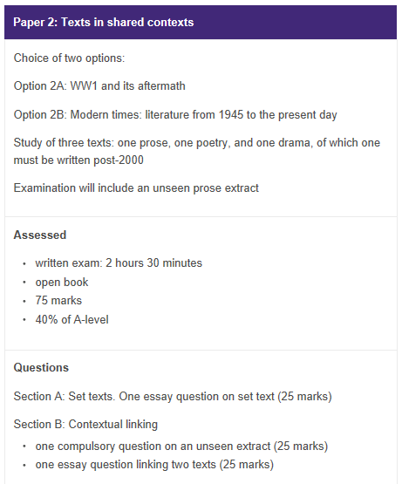
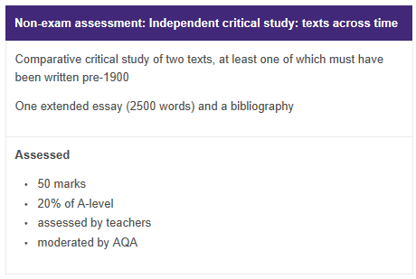

Progression:
♦ It typically leads to degrees in any English-based subjects, such as Literature, Creative Writing, Advertising and Journalism, but also those with high levels of intellectual engagement such as Philosophy, Law and History. An A Level in English Literature can also provide an excellent basis for Psychology and Sociology. As a facilitating subject, English Literature is a subject recognised as a gateway to any career requiring an insightful understanding of the world, and how its people think and behave.

Minimum Recommended Entry Requirements:
- English Lit Grade 6
- English Lang Grade 5

