Biology AQA (7402)

Biologists are scientists who study the natural world and all the living things in it, from the largest mammals down to our very own microscopic DNA.
They try to understand how animals and organisms work (including us humans), how we evolved and the things that can make us sick or improve our health.
Biologists use this knowledge to do things like try to stop the spread of disease, track down natural resources, improve public health, animal care and conservation and work out the true impacts of things like pollution.
Course Structure: Biology at A-level is divided into 8 topics.
YEAR 1
Biological Molecules –biochemistry underpinning all life on Earth including structure of carbohydrates, lipids and proteins, nucleic acids and water.
Cells – cell ultra-structure, cell division, the structure of and movement of substance across cell membranes, defence mechanisms and immunity.
Exchange between organisms and their environment – gas exchange, digestion and absorption, mass transport in animals (heart and circulation) and plants (xylem and phloem).
Genetic information, variation and relationships between organisms – DNA, genes, chromosomes, protein synthesis, meiosis, genetic diversity, adaptations and biodiversity.
YEAR 2
Energy transfer in and between organisms – photosynthesis, respiration, energy and ecosystems and nutrient cycles.
Organism’s response to their environment – nervous coordination, hormonal coordination, control of heart rate, receptors, muscle contraction and homeostasis.
Genetics, populations, evolution and ecosystems – inheritance, populations, evolution, speciation and ecosystems.
Control of gene expression – transcription, translation, mutations, stem cells, cancer, genome projects, gene technology and genetic fingerprinting.
Practical Endorsement.
Practical skills are developed throughout the course. There are five competencies that are monitored and reported on:
1. Follows written procedures.
2. Applies investigative approaches and methods when using instruments and equipment.
3. Safely uses a range of practical equipment and materials.
4. Makes and records observations.
5. Researches, references and reports.
Records of practical work are kept in laboratory books and 12 Core practicals must be completed as part of the A Level (6 in Year 12 and 6 in Year 13).
The competencies are assessed by the teacher(s). Content relating to the Core practicals and associated skills will be assessed through questions in the exam papers.

Course delivery: Lessons are a mixture of lecture style learning, practical work, problem solving and application of knowledge. Students will be asked to: solve mathematical problems, research methods, develop practical competencies, analyse data and explain a range of key biological concepts such as: cells as the units of life, biochemical processes and organisms in their environment. If mastered, learners can use the concepts to understand unfamiliar subject-related material.

Assessment:
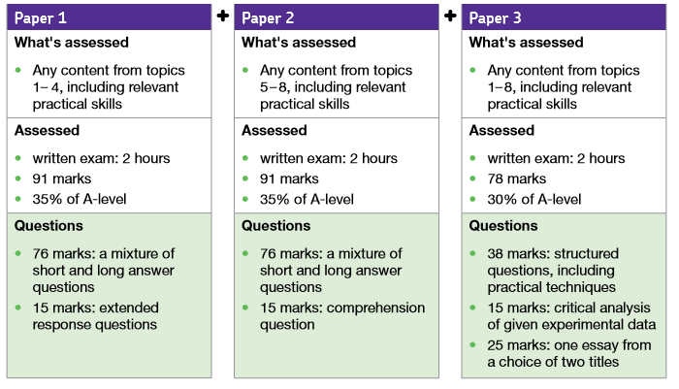

Resources and costs:
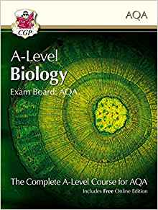
Students will need to purchase a text book to accompany the course approx. £20.
Year 2 – field trip – approx. £100

Progression:
Biology is a key subject for lots of STEM careers, particularly in healthcare, medicine and jobs involving plants or animals. The list is pretty long and includes: nursing, dentistry, forensic science, psychology, physiotherapy, botany, environmental science, zoology, geology, oceanography, pharmaceuticals, energy, teaching, science writing, genetics and research.
“It is also important to remember that Biology is excellent preparation for non-scientific careers, thanks to the skills it provides – everything from analytical thinking to writing reports.”
Minimum Recommended Entry Requirements:
- Biology Grade 6 (triple)
- Combined science 6-6
- 5 in Maths would also be desirable.

