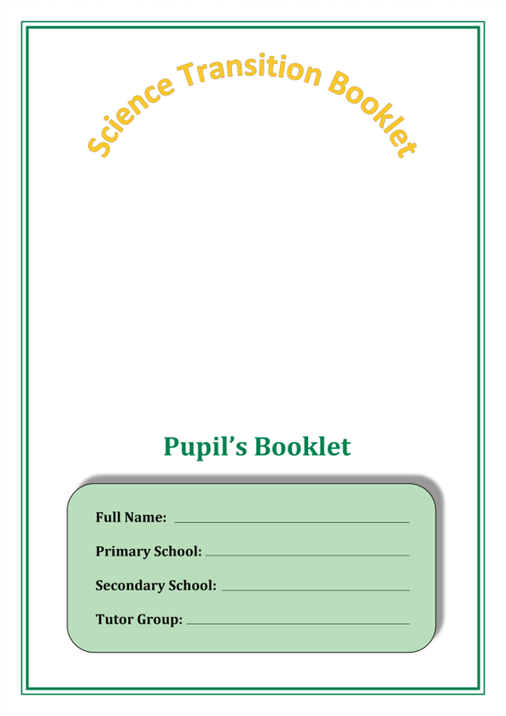

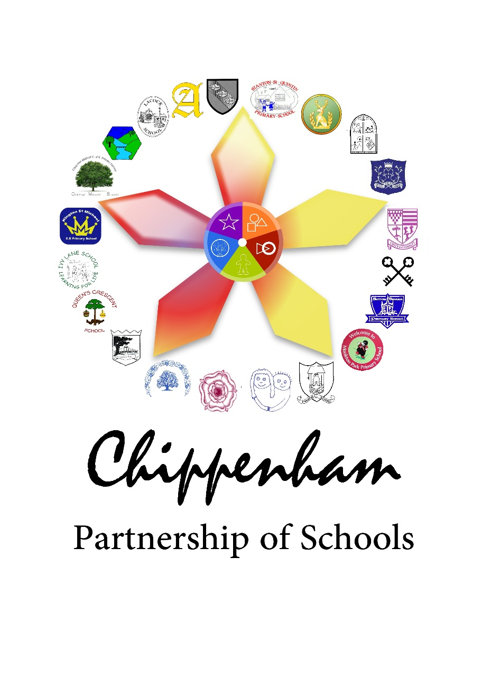

**Science Lab Equipment**

In science practical’s you will be using lots of specialist apparatus. You will need to be able to draw scientific diagrams of apparatus.

|  |  |  |  |
| --- | --- | --- | --- |
| **Equipment Photo** | **Equipment Name** | **Equipment Diagram** | **What is it used for?** |
|  | Tripod |  |  |
|  | Filter Funnel |  | A beaker is a glass container with a flat bottom that scientists use to hold liquids. |
|  | Beaker |  |  |
|  | Test Tube |  |  |
|  | Conical Flask |  |  |
|  | Measuring Cylinder |  |  |
|  | Bunsen  Burner |  |  |

Below draw lines to match the photo with the name of equipment, then with the scientific diagram. Look up and write the use of each piece of apparatus. The first one is done for you.

Have a look at the apparatus below and see if you can draw the scientific diagram using the table above to help you.

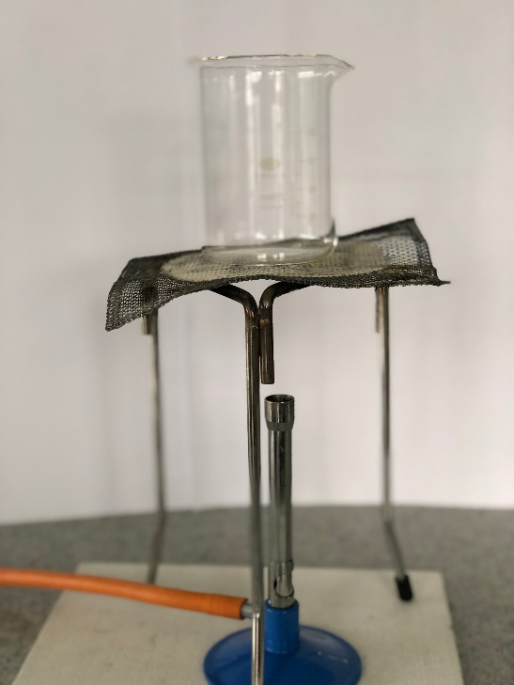

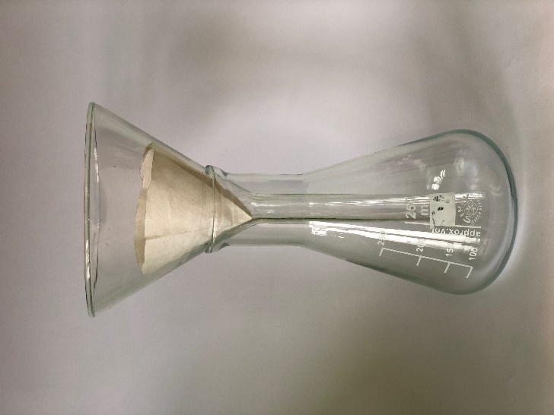

**Extension Task**

What apparatus is needed for distillation? Draw a diagram of the apparatus set up and find out what it is used for.

**In science lessons at Abbeyfield you will use lots of different apparatus. Locate the apparatus in the word search below.**

Beaker

Measuring cylinder

Conical flask

Gauze

Safety goggles

Filter funnel

Pipette

Clamp stand

Clamp

Thermometer

Evaporating basin

Crucible and lid

Heatproof mat

Tripod

Test tube

Test tube rack

Test tube holder

Pestle and mortar

Watch glass

Bunsen burner

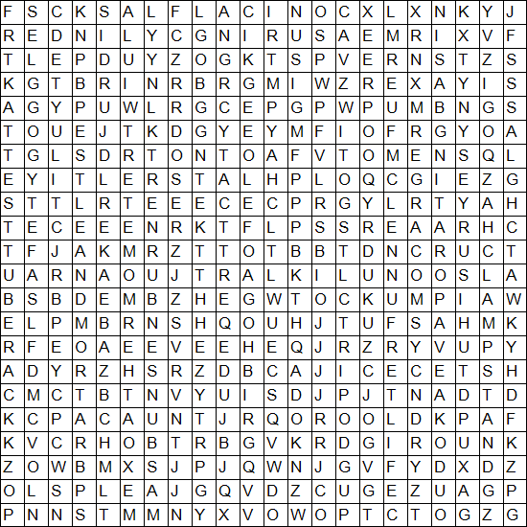

**Notes**

**Notes**



