A Level Geography (OCR)
WHY STUDY A-LEVEL GEOGRAPHY?
As a highly regarded facilitating subject, A Level Geography is a good option for students considering Russell group or other university courses, as well as Degree or Higher Apprenticeships.
Royal Geographical Society - Why you should study geography (rgs.org)
Graduates with Geography degrees are amongst the most employable students and are able to access a wider range of career pathways, including business, international relations, criminology, law planning, constructive, and even teaching. Basically, the number of careers you can’t study with a Geography degree are far fewer than those you can!
The course itself offers something for everyone, from looking at human rights, to considering the role of international trade in globalisation and how the current climate emergency is changing our physical and human systems on a scale never see before.
Geography is a dynamic and fast paced subject and to be successful you will need an awareness of current national and global issues – wider reading is fundamental to accessing higher grades.
For example, how has Covid19 impacted on our urban areas, and natural ecosystems, and how the UK leaving the EU in January 2020 has affected our global position in trade and international migration.
MINIMUM ENTRY REQUIREMENTS:

- Geography Grade 5 (it is preferable that you have studied Geography at GCSE, although not essential)
- English Grade 5
- Maths Grade 5
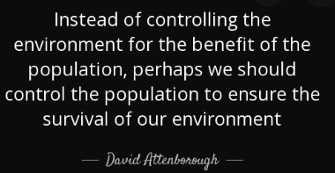
If you enjoyed your GCSE Geography, why not continue to A-Level and learn even more about where we live and how to be an active citizen in inspiring future generations to change the World for the better.

SPECIFICATION & ASSESSMENT
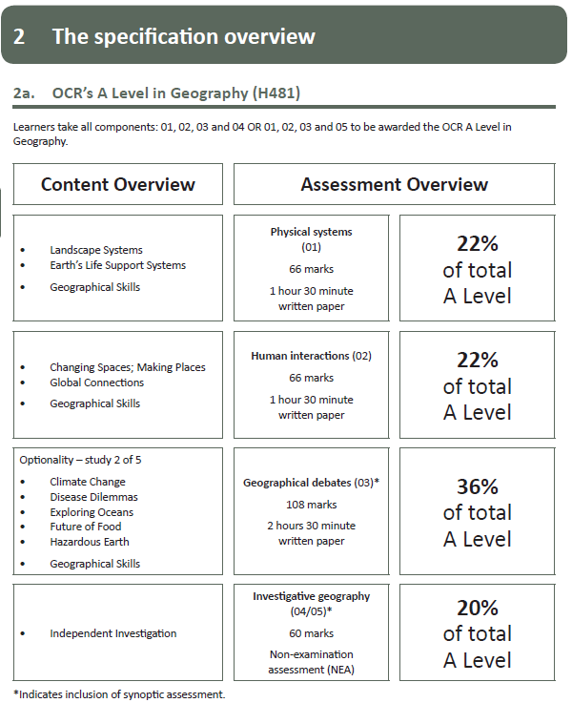

If you have any questions about the course content, exam structure, or your suitability for A-Level Geography, please email Miss Jones: sxj@abbeyfield.wilts.sch.uk

