English Language AQA 7702

Do you have an interest in how language is acquired and how it develops across time? Are you fascinated by wide ranges of literature in different genres? Did you enjoy linking the literature you studied at KS4 to the contexts in which they were written? The new English Literature course is varied and accessible, suiting those with open and enquiring minds.

Course Structure: The two year course, culminating in A level exam is made up of three modules:

Language, the individual and society
The aim of this part of the subject content is to introduce students to language study, exploring textual variety and children’s language development. This area of study introduces students to methods of language analysis to explore concepts of audience, purpose, genre, mode and representation. It also introduces students to the study of children’s language development, exploring how children learn language and how they are able to understand and express themselves through language.
Language diversity and change
The aim of this area of study is to allow students to explore language diversity and change over time. Students will study the key concepts of audience, purpose, genre and mode and will explore language in its wider social, geographical and temporal contexts. They will explore processes of language change. This part of the subject content also requires students to study social attitudes to, and debates about, language diversity and change.
Language in Action
The aim of this area of study is to allow students to explore and analyse language data independently and develop and reflect upon their own writing expertise. It requires students to carry out two different kinds of individual research: • a language investigation (2,000 words excluding data) • a piece of original writing and commentary (750 words each). Students can choose to pursue a study of spoken, written or multimodal data, or a mixture of text types, demonstrating knowledge in areas of individual interest.

Course delivery: Lessons are a mixture of discussion, small group work and taught sessions. Students will be asked to give presentations, research ideas, develop their ability to synthesise and develop an argument and to write clearly and expertly. Wider reading will be encouraged to allow students to develop a confident command of language develops and changes, so independence and energy is required.

Assessment:

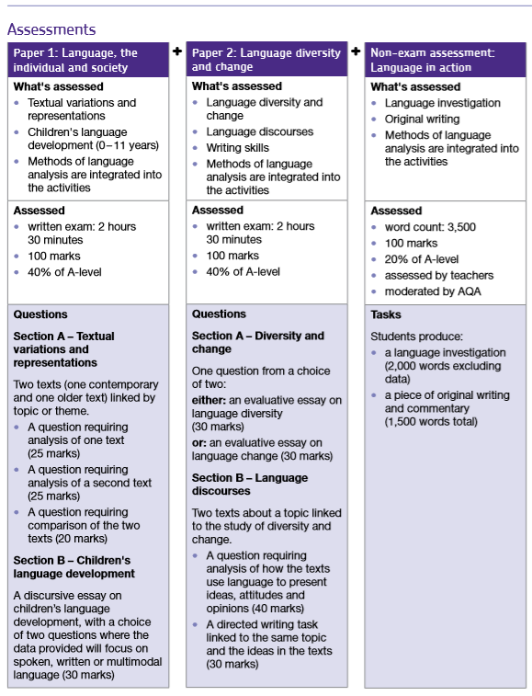

Progression:
♦ An A Level in English Language can open doors to a very wide range of careers and It typically leads to degrees in any language or communication-based subjects, such as Linguistics, Creative Writing, Advertising and Journalism, Law, teaching and many others.
Minimum Recommended Entry Requirements:
5 at GCSE English Language and English Literature.
Students with a 4 may be considered if they have a clear interest in the subject and good essay writing skills.

