Physics AQA (7408)

Physicists are the greediest scientists around as they’ve chosen to study the entire universe. No big deal...

Physicists look for all the hidden laws that explain why all matter (that’s every physical thing) and energy in the known universe exists, where it comes from and how it behaves the way it does.

Physicists use the laws they uncover to develop new materials, machinery, and technology to improve our lives and help us explore the universe further, from computers to telescopes and spacecraft.

Course Structure: The A level course contains the following core content:
AS  1 Measurements and their errors  2 Particles and radiation  3 Waves  4 Mechanics and materials  5 Electricity | A level  6 Further mechanics and thermal physics  7 Fields and their consequences  8 Nuclear physics  With an option to complete one of the following units:  9 Astrophysics 10 Medical physics  11 Engineering physics  12 Turning points in physics  13 Electronics

Much of the AS course content is building on pupils skills and knowledge gained at GCSE.
The course requires pupils to apply their mathematics skills in many units and teaching is linked to pupils A level maths curriculum accordingly.

Practical Endorsement:
Practical skills are developed throughout the course. There are five competencies that are monitored and reported on:

1. Follows written procedures.
2. Applies investigative approaches and methods when using instruments and equipment.
3. Safely uses a range of practical equipment and materials.
4. Makes and records observations.
5. Researches, references and reports.

Records of practical work are kept in laboratory books and 12 Core practicals must be completed as part of the A level course. (6 in Year 12 and 6 in Year 13).

The competencies are assessed by the teacher(s). Content relating to the Core practicals and associated skills will be assessed through questions in the exam papers.

Course delivery: Lessons are a mixture of lecture style learning, practical work, problem solving and application of knowledge. Students will be asked to: solve mathematical problems, research methods, develop practical competencies, analyse data and explain a range of phenomena.

Assessment:
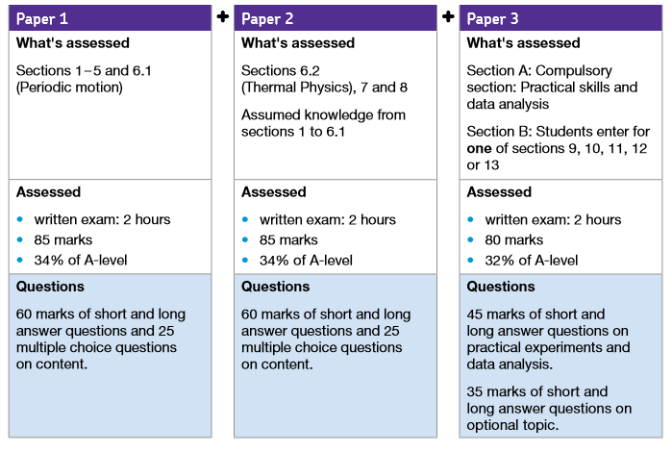

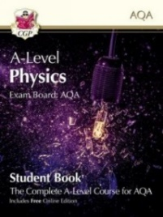
Resources:
Students will need to purchase a text book to accompany the course approx. £20. Students will also have access to Isaac Physics resources sponsored by Cambridge University. There are also numerous alternative texts and many past papers/mark schemes in the student shared area.

Field trips include Hinkley Point Nuclear Power Station in the UK.

Progression:
Physics is a vital subject for the majority of STEM (Science, Technology, Engineering & Maths) careers and you’ll find physicists everywhere, in industry, medicine, transport, government, universities, the armed forces, the secret service, games companies, research labs and more! Physics A level does not restrict a pupil in future pathways but offers so many opportunities.

Physics is especially helpful for jobs that involve building things and developing new technologies, including: engineering (flight, buildings, space, you name it…), astronomy, robotics, renewable energies, computer science, communications, space exploration, science writing, sports and games technology, research and nanotechnology. Many doctors studied physics.

Minimum Recommended Entry Requirements:
- GCSE Physics Grade 6 (triple)
- Combined Science 6-6
- Grade 7 in GCSE Mathematics is desirable.

