A LEVEL
PHOTOGRAPHY
2020/2021
AQA A Level Art & Design (Photography) 7206
Course Leader: Mr Allies-Curtis dac@abbeyfield.wilts.sch.uk
Why study Photography?
Learning to understand and use photography has become increasingly relevant in modern times do to the nature of our culture becoming so image led. Studying photography allows you to access the knowledge required to negotiate this visual literacy and become a skilled creator of images that seek to communicate ideas. Visual literacy through image making is an important skill to learn that is relevant to so many different industries and so is a highly transferable skill set.
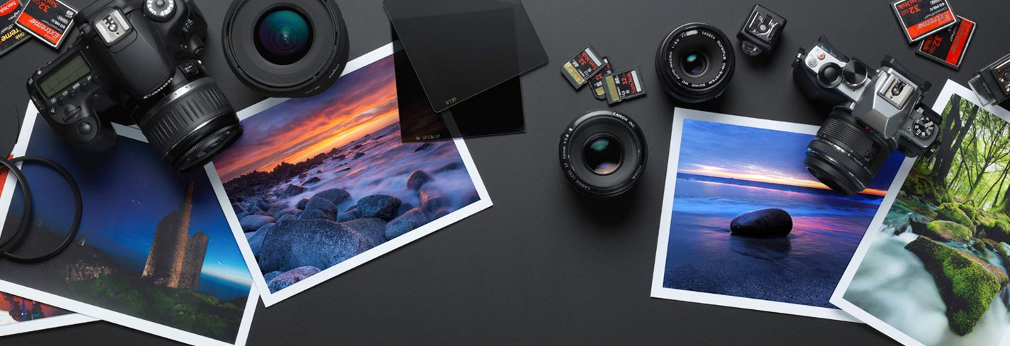
Alongside giving you the skills to be proficient in this visual language, by studying photography you will be embarking on a journey of self-expression, where you will be able to use photography to explore other ideas or activities that interest you and express what you think about them visually. The process of making images satisfies our innate human need to make things and as such contributes to the betterment of your wellbeing.

Course structure
Induction
A technical induction to the medium and subject of photography where you will learn how to use cameras, how to use lighting in the studio and how to edit photographs using Adobe Photoshop. You will also begin to experiment with different photography techniques in the darkroom and develop your skills in analysing photographs.
Component 1 – Personal Investigation
60% of overall grade
This is a practical investigation supported by written material. This means that you will work on a focused theme or topic, which will include:
- Researching and analysing the work of other photographers that relate to your theme and developing your ideas for your theme.
- Experimenting with and analysing different photographic techniques.
- Recording your research and experiments with detailed reflections and annotation in a sketchbook.
- Making and exhibiting a final set of photographs that resolve the topic that you have been investigating.
- Writing one essay that relates to your topic of investigation.
Component 2 – Externally set assignment
40% of overall grade
The exam board, AQA, will set a choice of eight titles to choose from. You will pick one of these and then complete a preparatory period of 9 weeks where you will investigate this topic in the same way as with the personal investigation, with research, experimentation and reflection. You then have an exam of 15 hours, spread across a number of days, to produce a final outcome for this topic. There is no essay for this component.

Course Delivery
The course includes a variety of teaching methods, including practical workshops in the darkroom, photography studio and digital computer suite, as well as an increasing level of independent study from yourself as you develop your personal investigation.
There will be a variety of one-to-one and group tutorials to enable you to share and develop your work with your teacher and peers. You are encouraged to visit photography exhibitions and a class trip to do this as well as take pictures as a group on location will be organised.
There is flexibility within the course for you to explore areas that most interest you, including portraiture, landscape, still life, documentary, fashion, experimental, multimedia, installation and moving image.
Assessment
Both components of work will be assessed by Abbeyfield School and moderated by an external examiner from AQA. Work is marked according to the AQA assessment objectives:
- AO1 - Develop ideas through sustained and focused investigations informed by contextual and other sources, demonstrating analytical and critical understanding.
- AO2 - Explore and select appropriate resources, media, materials, techniques and processes, reviewing and refining ideas as work develops.
- AO3 - Record ideas, observations and insights relevant to intentions, reflecting critically on work and progress.
- AO4 - Present a personal and meaningful response that realises intentions and, where appropriate, makes connections between visual and other elements.
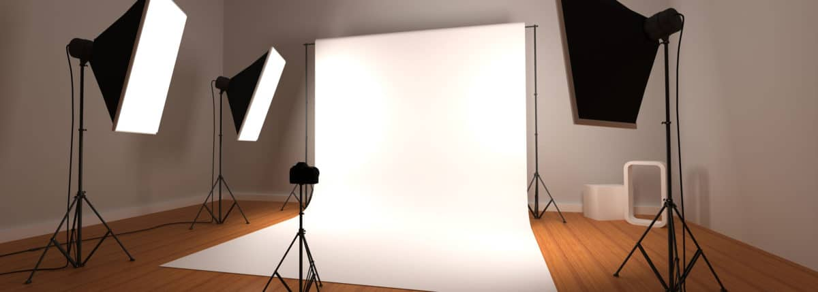

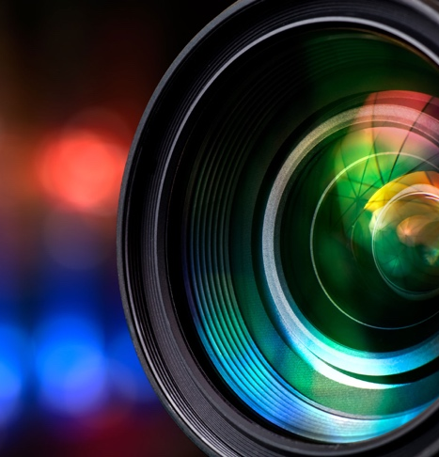
Resources
We have darkroom here at Abbeyfield that enables us to process and print black and white negatives, as well as exploring some of the more experimental traditional techniques, such as cyanotypes and photograms.
We have a dedicated photography studio equipped with lights and a range of reflectors and diffusers to give complete control over lighting.
We have Digital Single Lens Reflex (DSLR) cameras that you can use in school, but students are required to have their own camera for this course. If you are not sure about what camera is appropriate, please do get in touch.
We have a digital computer suite equipped with Adobe Creative Cloud suite of programmes for post-production editing.
Progression
This course will prepare you with the skills you need to access higher education either on an Art Foundation course or possibly directly onto an undergraduate degree. It will also give you the transferable photographic skills to work in a variety of creative industries work settings, including events, fashion, and studio photography. The creative thinking and analytical skills developed during the course are highly transferable to almost any setting and will be an enormous benefit to your personal development.
Minimum entry requirements
English Grade 4

Optional: Art Grade 4 if studied at GCSE

