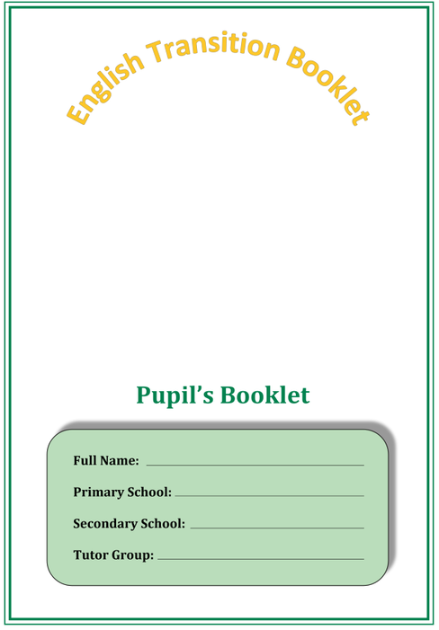

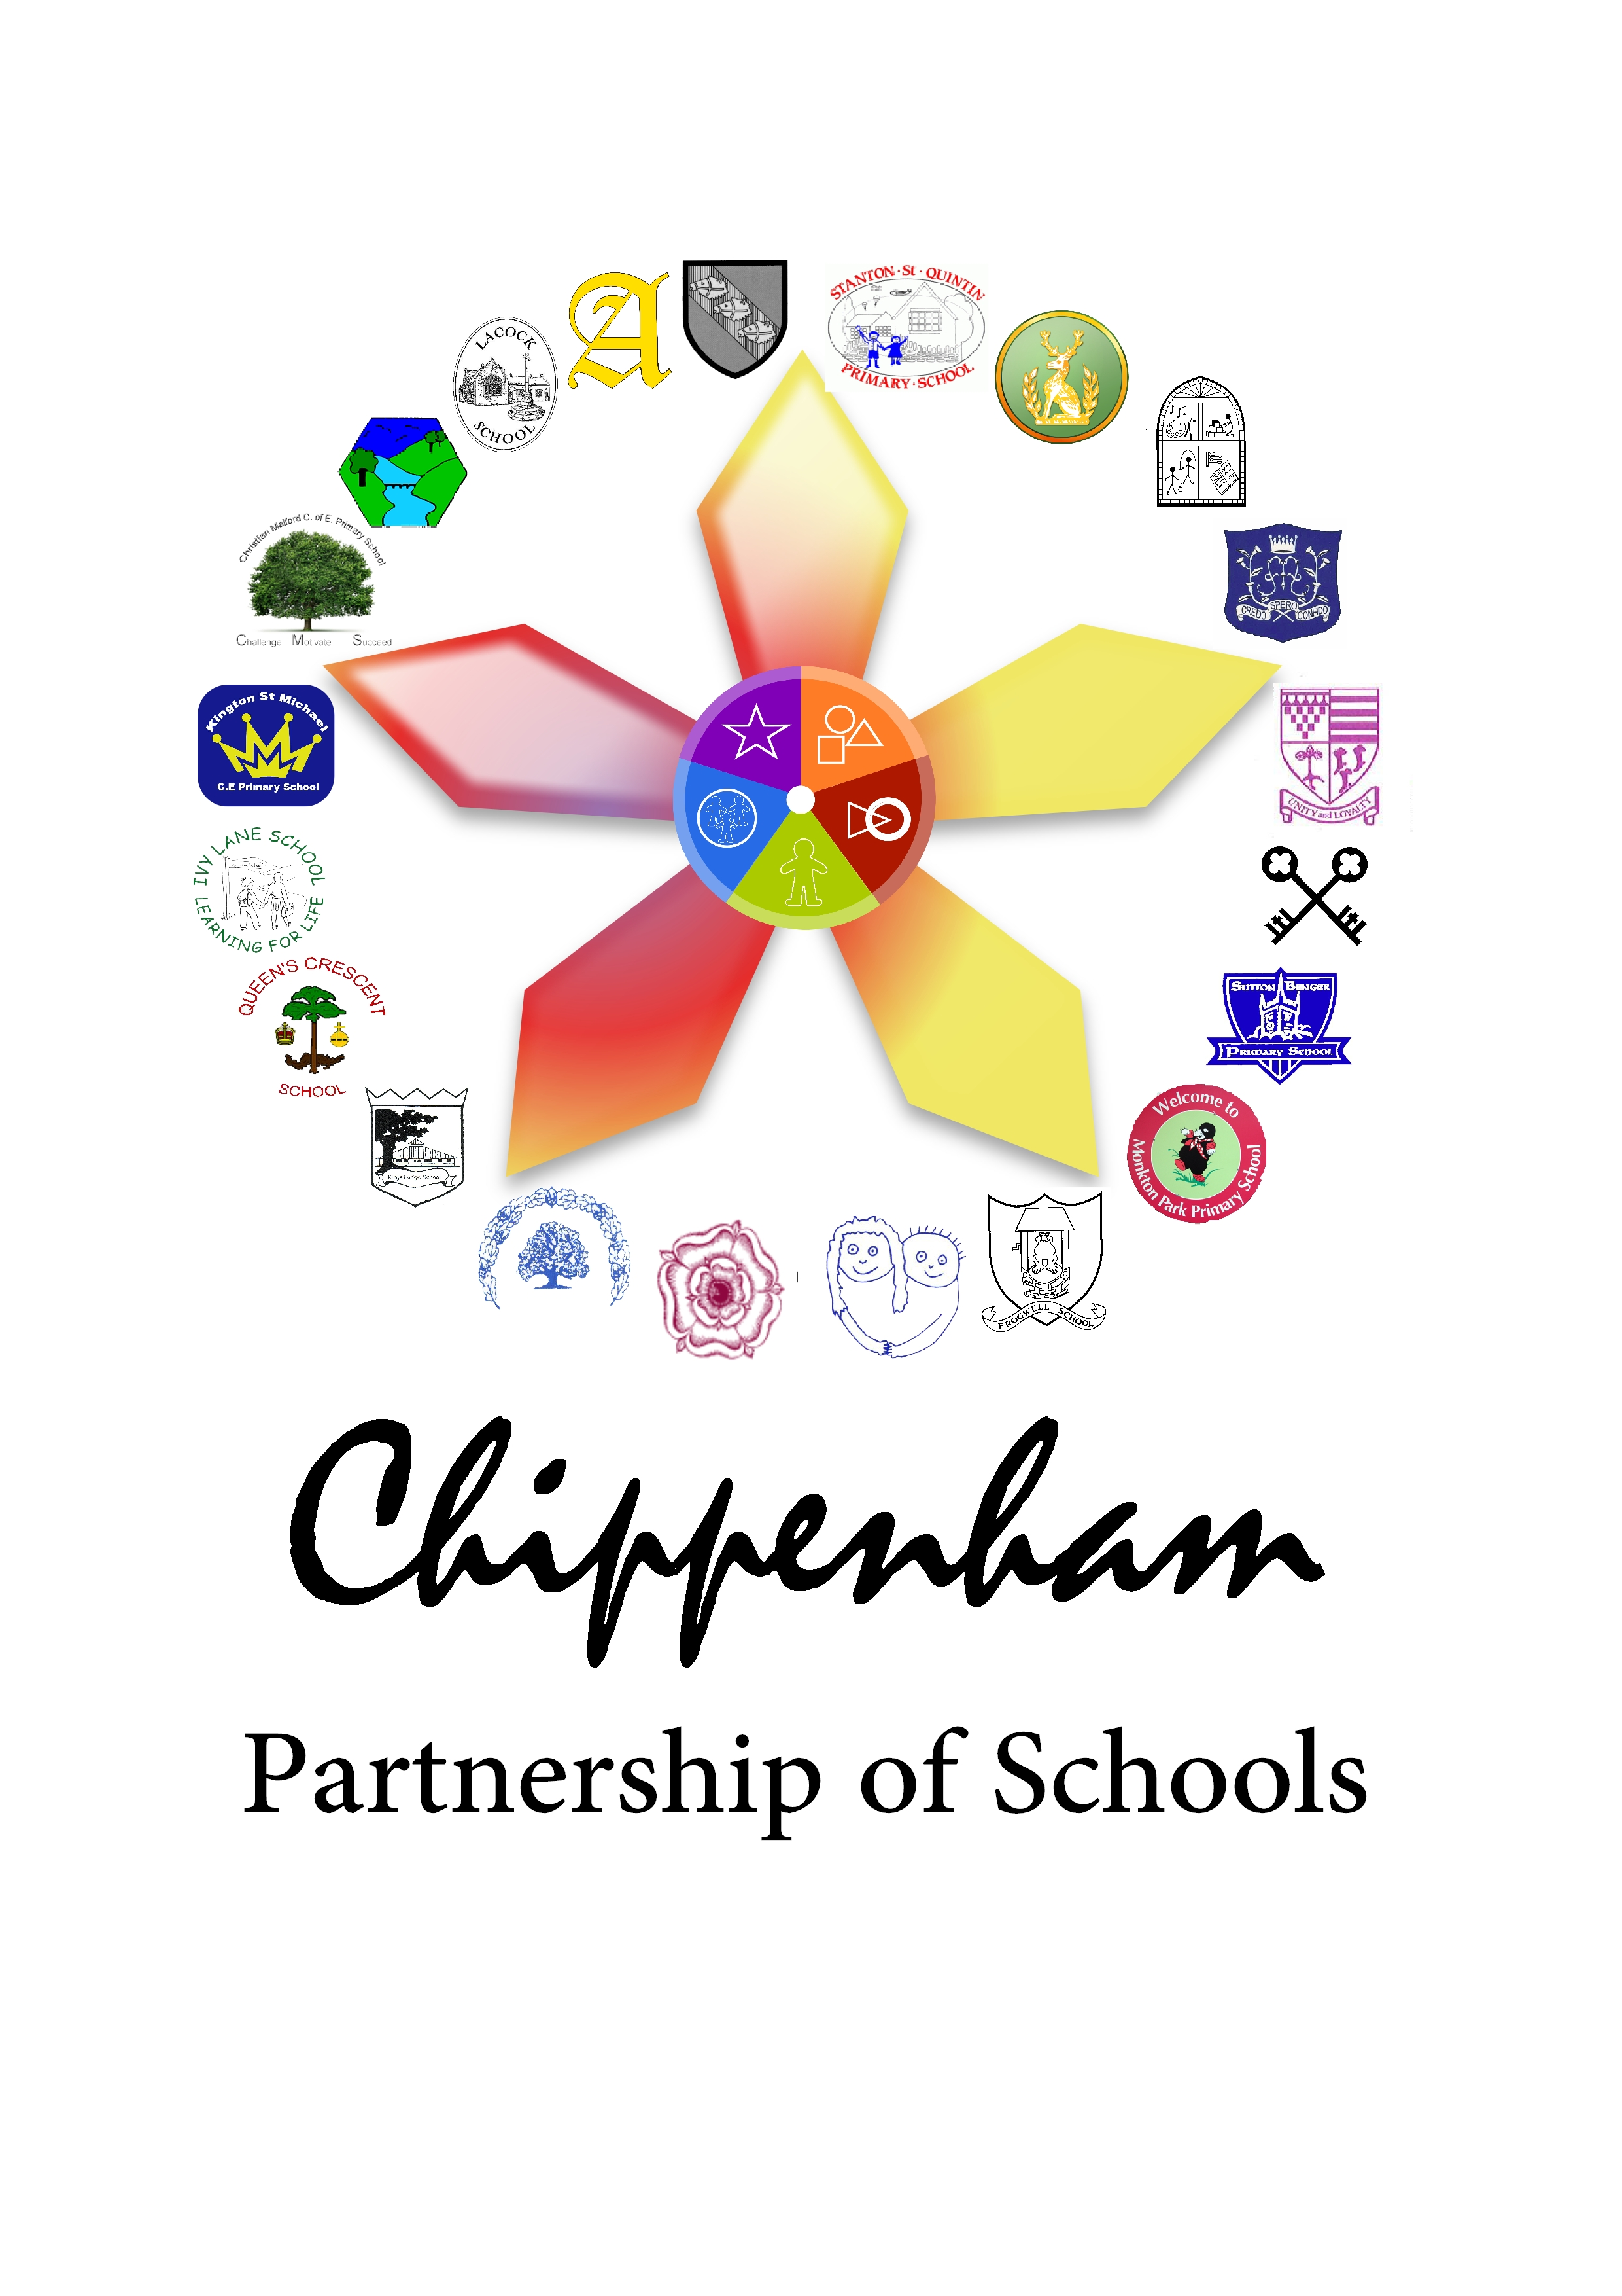

Showcasing my Skills

We would love to know all about your strengths in English and what skills you’re really proud of and want to showcase as you come into secondary school.
Using the key below, draw a different smiley for how confident you feel with each skill.
= really confident

= quite confident = not very confident

Skill | How confident are you with…
Reading out loud in class?

Writing for a long period of time?

Using imagination to come up with creative ideas on my own?
Presenting my work neatly?

Spelling words correctly?

Using a range of punctuation accurately?
Use this space to tell us about anything else you are really proud of:

How about anything else you find challenging?

Which skill are you most looking forward to showcasing and why?

Reading skills

- Look at the words below. Who do you think would use language like this? How old might they be? Make a prediction on the poem or speaker based on these words.
Yellowwellies
millionbillionwillion
Wolves and monsters
Teacher

- Read through the poem ‘First Day at School’ on your own. Underline all the words used to describe how the boy feels on his first day at school, and write a list below of the emotions he feels:

- Why might the boy ask so many questions in the poem? Write your ideas below.

- Why do you think there are so many short sentences in the poem? What do they suggest about the boy’s feelings?

- In the last stanza (paragraph of a poem), the boy says he has forgotten his name. What does this suggest about how he feels? Try and use as many of the lines below as you can to explain your ideas.

- Try and think about how you felt on your first day at primary school. Were you a little nervous or excited?

-> You could draw an image of you on your first day
-> You could create a freeze frame showing your emotions.
Challenge: What do you think the poet might be trying to tell us about the first day at primary school for some five-year olds?

First Day at School – Roger McGough
A millionbillionwillion miles from home
Waiting for the bell to go. (To go where?)
Why are they all so big, other children?
So noisy? So much at home they
Must have been born in uniform
Lived all their lives in playgrounds
Spent the years inventing games
That don't let me in. Games
That are rough, that swallow you up.

And the railings.
All around, the railings.
Are they to keep out wolves and monsters?
Things that carry off and eat children?
Things you don't take sweets from?
Perhaps they're to stop us getting out
Running away from the lessins. Lessin.
What does a lessin look like?
Sounds small and slimy.
They keep them in the glassrooms.
Whole rooms made out of glass. Imagine.

I wish I could remember my name
Mummy said it would come in useful.
Like wellies. When there's puddles.
Yellowwellies. I wish she was here.
I think my name is sewn on somewhere
Perhaps the teacher will read it for me.
Tea-cher. The one who makes the tea.

- Poems
Writing skills
Now you have showcased your reading skills, we would like to see you at your best in one (or more) of the following writing tasks.

Task 1:
Imagine you are visiting the primary school of the boy in the poem. Write a speech to deliver to the class offering advice and reassurance about what primary school is really like.
You could write about:
- The best things about primary school
- Why there’s no need to be nervous
- How to make friends with other children.
Challenge: Think about your language choices. How could you use language to make your speech clear and engaging for younger children?

Task 2:
Write your own poem about your first day at school. You could create a character if you can’t remember your own experience.
Think about:
- How you felt/what you thought
- What questions you had
- How to use words to show feelings and thoughts effectively.
Challenge: Can you use different sentence lengths/types to reflect the emotions in the poem like in the poem ‘First Day at School’? (Hint: What length might sentences be if you are scared or excited?)

Task 3:
Write a letter to your new Year 7 English teacher to introduce yourself and tell them about the three main things that make you a great student.
Think about:
- A quality that you have that you are really proud of, such as being helpful or polite.
- What makes you a great learner.
- Examples of where you have showcased these qualities.

Challenge: Think about how you can use a range of language, such as adjectives and adverbs, to best explain your qualities.

Planning Page
Task Chosen:

________________________________________________________________________________________________________________________________________________________________________________________________________________________________________________________________________________________________________________________________________________________________________________________________________________________________________________________________________________________________________________________________________________________________________________________________________________________________________________________________________________________________________________________________________________________________________________________________________________________________________________________________________________________________________________________________________________________________________________________________________________________________________________________________________________________________________________________________________________________________________________________________

Final Draft

________________________________________________________________________________________________________________________________________________________________________________________________________________________________________________________________________________________________________________________________________________________________________________________________________________________________________________________________________________________________________________________________________________________________________________________________________________________________________________________________________________________________________________________________________________________________________________________________________________________________________________________________________________________________________________________________________________________________________________________________________________________________________________________________________________________________________________________________________________________________________________________________

________________________________________________________________________________________________________________________________________________________________________________________________________________________________________________________________________________________________________________________________________________________________________________________________________________________________________________________________________________________________________________________________________________________________________________________________________________________________________________________________________________________________________________________________________________________________________________________________________________________________________________________________________________________________________________________________________________________________________________________________________________________________________________________________________________________________________________________________________________________________________________________________________________________________________________________________

Reflection

Which task in the booklet did you enjoy the most? Why?

Tell us how you completed the writing task. Circle the option that applies to you.
Was it:
In a small group?
On your own?
With a teacher or teaching assistant?

What are you most looking forward to about secondary school?

We look forward to meeting you in September and getting to see you at your best!

Notes

Produced by Abbeyfield School, in collaboration with Sheldon School, Hardenhuish School and the Primary Cluster Group.

