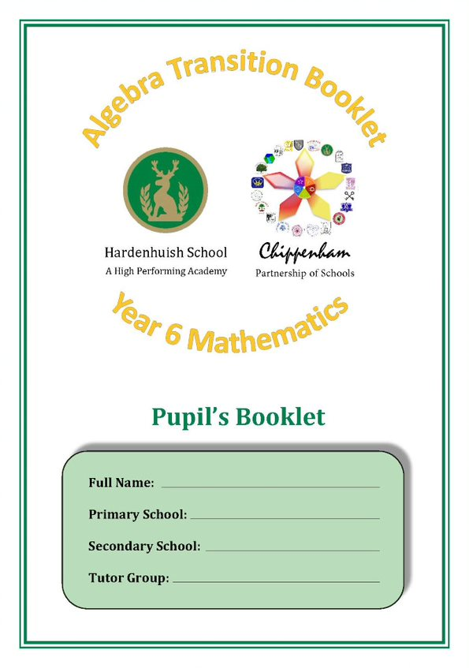





**Welcome**

You will first use this booklet in some of your Year 6 Mathematics lessons and then later in your new school when you are in Year 7. This booklet contains four lessons, two investigations and a self-assessment section.

Each lesson is divided into sections so that you can choose questions which will either support or challenge you. It will help show your new secondary school teacher your current level in Mathematics. This booklet is for your own work, but you can ask for help. There are examples and space for workings out, as well as answers.

Enjoy the algebra work you do in your Mathematics lessons when using this booklet. It will show you and your teachers the progress you are making!

But what is algebra?

The a-word scares people – just ask your parents! However, it need not be a problem. Think about climbing a tree; as long as you remember to hang on, you won’t fall off. Algebra is like that – remember what you’re doing and you‘ll be fine.

Algebra is all about using letters to represent numbers, then doing stuff with them. This makes life easier – honest!!!

j0398129[1]

**Fred's Cafe**

Welcome to Fred’s Café. When Fred is taking an order, he uses a short-hand code. You can see Fred’s code written on the menu below.

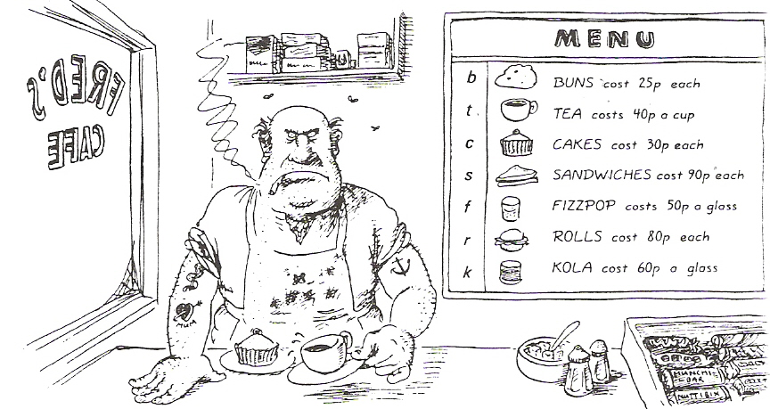

Write these orders in Fred’s code. The first one is done for you.

1) The cost of a cup of tea and a sandwich: *t + s*

2) The cost of a cup of tea and a cake: ………………………

3) The cost of a glass of kola and a bun: ………………………

4) The cost of a bun, a cup of tea and a sandwich: ………………………

5) The cost of a cup of tea and a glass of kola: ………………………

Here are six more orders. Write them using Fred’s code. The first one is done for you.

1) 2 teas: *2t*

2) 3 cakes: …………..

3) 2 kolas: …………..

4) 4 teas: …………..

5) 3 sandwiches: …………..

6) 2 teas & a bun: …………..

Use Fred’s menu to work out the amount of each bill.

The first one is done for you.

1. t + c = 40 + 30 = 70 pence
2. b + c =………………………………….
3. t + k =………………………………….
4. b + t =………………………………….
5. f + c =………………………………….
6. s + f =………………………………….
7. t + s =………………………………….
8. f + b + s =…………………………..
9. c + s + t =……………………………

10)s + s + t + k =…………………….

**Extension:**

Use the menu to work out Fred’s bill:

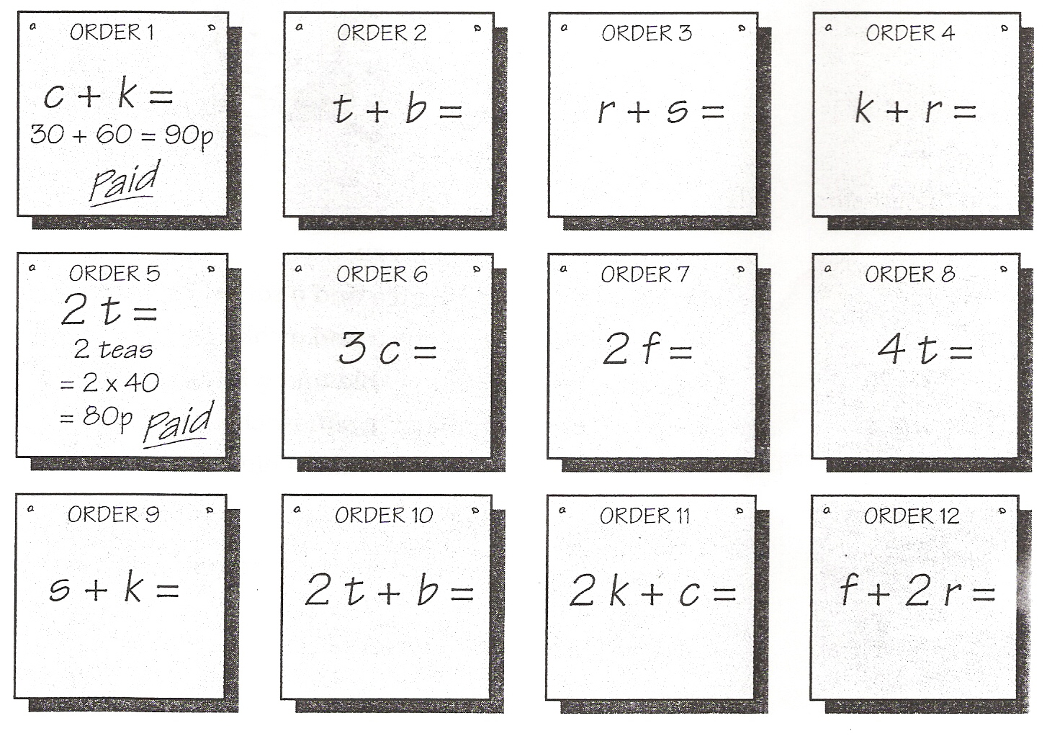

**Puzzling Algebra**

Algebra can also be used to solve puzzles. The letters or pictures in each row or column add up to the numbers shown. Try to find the values of all the characters and then find the value represented by the question mark for each question.

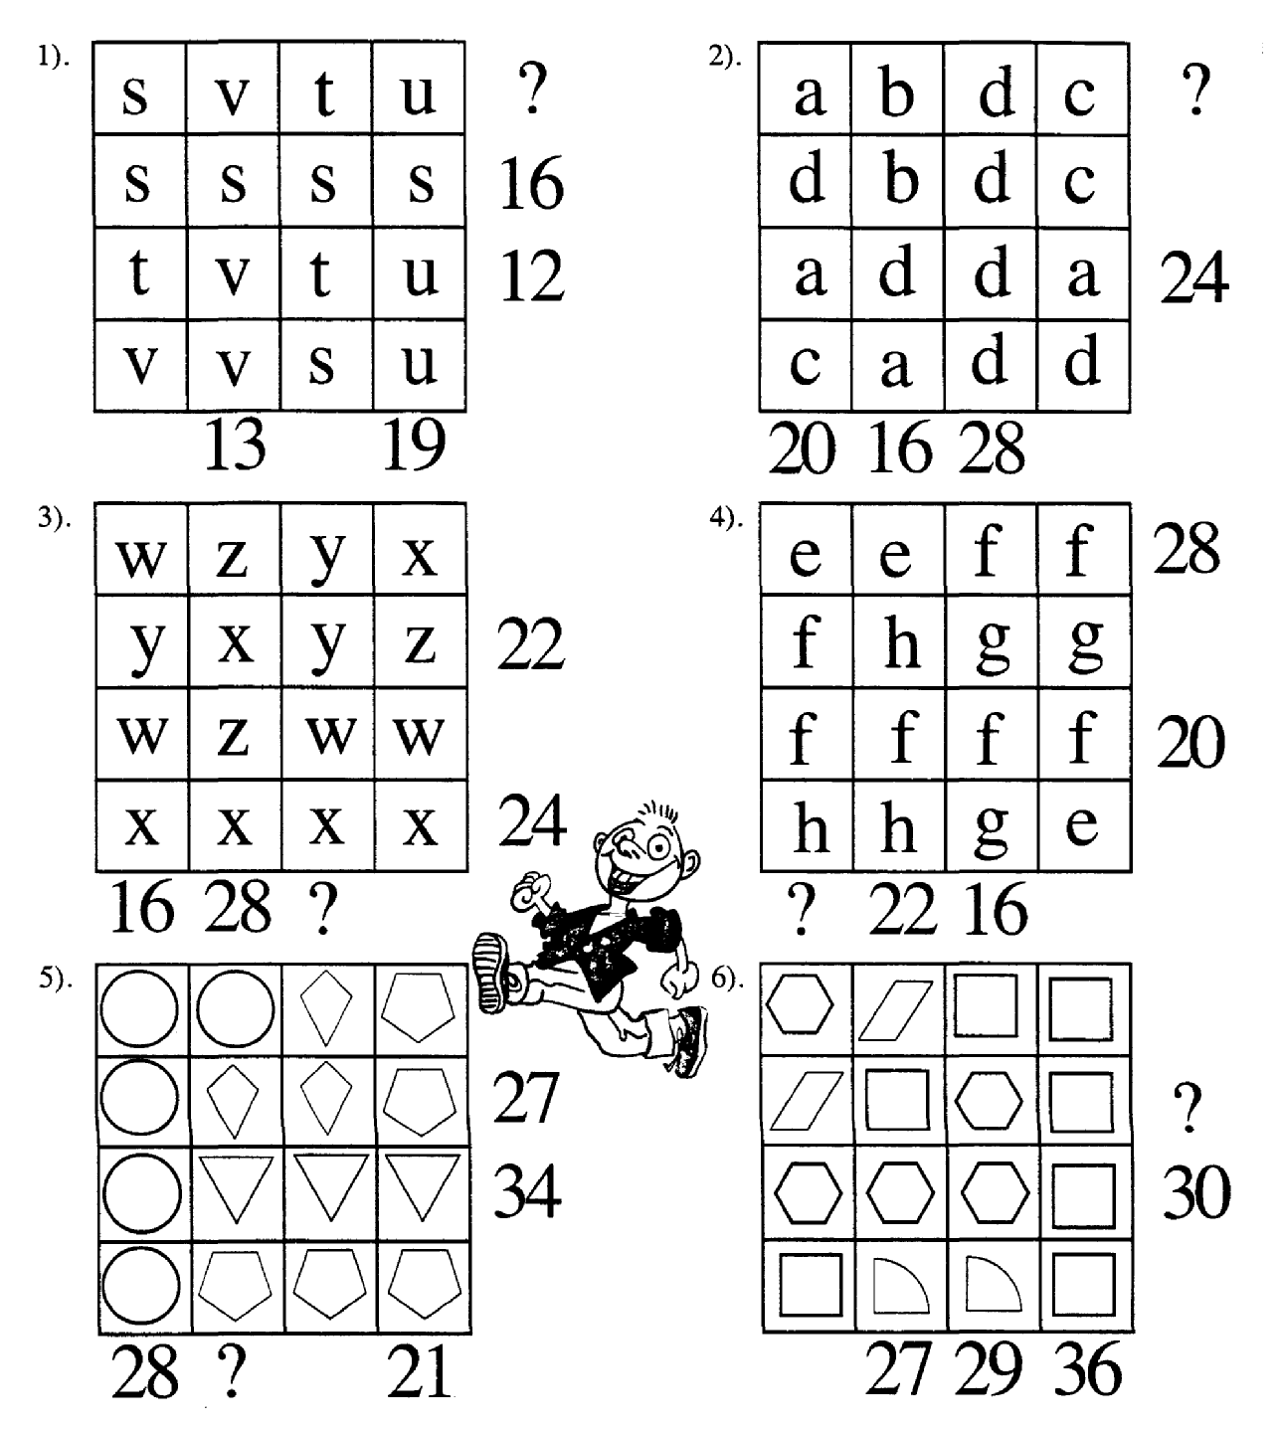

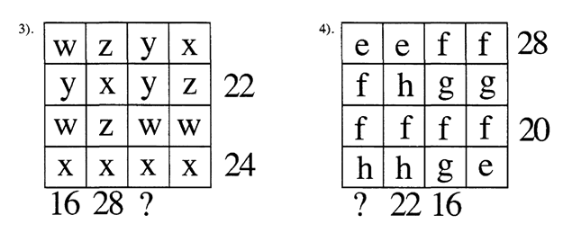

**Balancing the Scales 1**

Work out the value of the weight x on each of the scales below:



a) b) c)

*x* = …….. *x* = …….. *x* = ……..

**Introduction:** In the same way solve these equations (find a value for *x*).

1) *x* + 9 = 6 + 5 *x* = ……..

2) 9 + *x* = 13 + 8 *x* = ……..

3) *x* + 7 = 20 + 1 *x* = ……..

4) 15 + 15 = *x* + 6 *x* = ……..

Now try these equations involving subtraction:

1) *x* - 4 = 6 + 6 *x* = ……..

2) 9 + *x* = 13 - 3 *x* = ……..

3) *x* - 7 = 20 + 7 *x* = ……..

4) 16 - *x* = 5 + 6 *x* = ……..

**Consolidation:** The scales below show some two step equations.

a) b) c) d)

   

*x* = …….. *x* = …….. *x* = …….. *x* = ……..

Solve the following equations in the same way.

1) 2*x* + 1 = 9 *x* = ……..

2) 2*x* + 11= 21 *x* = ……..

3) 20 = 2*x* + 14 *x* = ……..

4) 7 = 2 *x* + 4 *x* = ……..

**Extension:** Try these equations involving subtraction:

1) 2*x* – 5 = 3 2) 2*x* – 1 = 17 3)16 = 2*x* – 4 4) 11 = 2*x* - 8

*x* = …….. *x* = …….. *x* = …….. *x* = ……..

**Balancing the Scales 2**

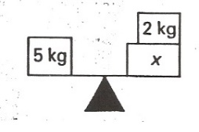

*Example:* The scale is balanced, so *x* must be 3kg.

Try to work out the weight of the letter in each question, write your answers at the bottom of the page in the space provided.

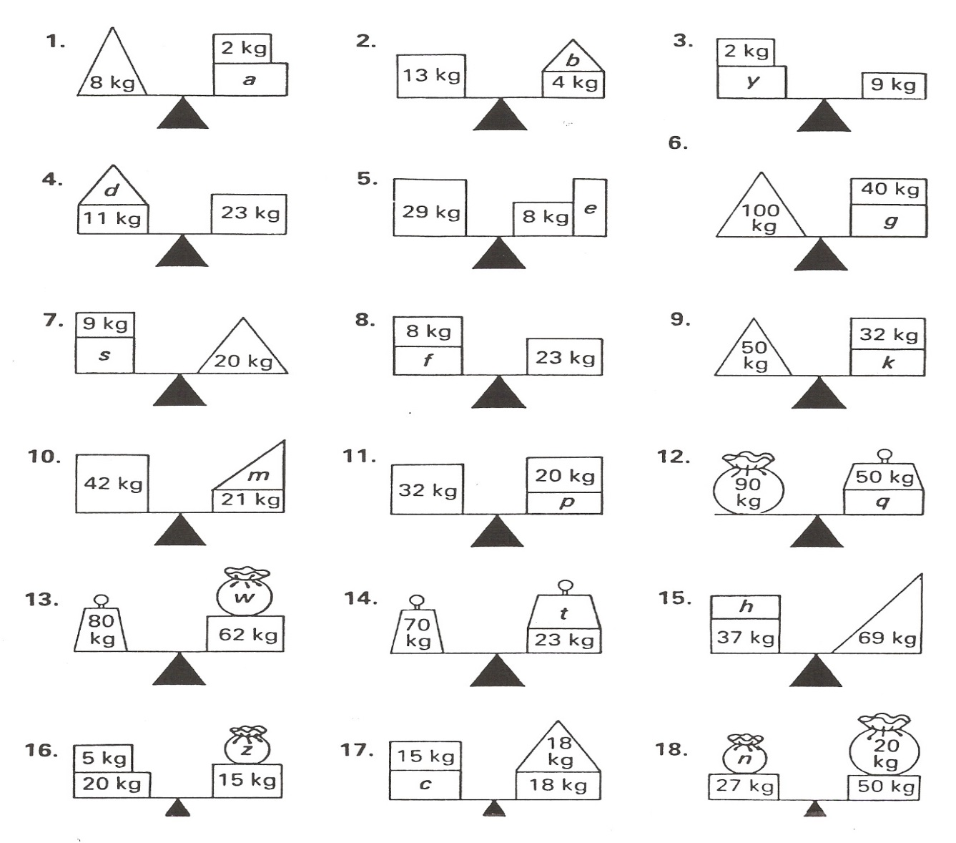

**Extension**

**Introduction**

**Consolidation**

**Introduction Consolidation Extension**

1. a = ……..
2. b = ……..
3. y = ……..
4. d = ……..
5. e = ……..
6. g = ……..
7. s = ……..
8. f = ……..
9. k = ……..

10) m = ……..

11) p = ……..

1. q = ……..
2. w = ……..
3. t = ……..
4. h = ……..
5. z = ……..
6. c = ……..
7. n = ……..

**Solving Equations**

Can you find out what the letters stand for?

**Introduction:**

1. a + 3 = 7 a = ……
2. 6 + c = 14 c = ……
3. 24 – e = 13 e = ……
4. 10 = 5 x k k = ……

**Consolidation:**

1. 14 ÷ p = 2 p = ……
2. y + 6 = 14 y = ……
3. 11 = t + 9 t = ……
4. 5 x n = 35 n = ……
5. f + 2 = 17 f = ……

6) 15 = h + 3 h = …...

7) 23 – u = 17 u = ……

8) 9 x j = 54 j = ……

5) 8 = 16 ÷ w w = ……

6) 18 – g = 13 g = ……

7) 3 x m = 18 m = ……

8) 40 – f = 25 f = …….

**Extension:**

1. 3f + 6 = 18 f = ……
2. 5g + 2 = 32 g = ……
3. 2w + 7 = 17 w = ……
4. 7k + 8 = 22 k = ……
5. 4q + 4 = 16 q = ……
6. 2y + 6 = 24 y = ……
7. 5g + 9 = 14 g = ……
8. 10d + 11 = 91 d = ……

**Well done! You’ve just solved your first algebraic equations!**

**Substitution**

In each of questions below substitute the numbers into the expressions in the box.

**Introduction:**

A + 3 1a) A = 3 …… b) A = 99 ……. c) A = 37 …… d) A = -4 ……

B - 4 2a) B = 6 …… b) B = 9 ……. c) B = 20 …… d) B = 2 ……

15 – C 3a) C = 4 …… b) C = 9 ……. c) C = 12 …… d) C = 20 ……

**Consolidation:**

D + 14 1a) D = 7 …… b) D = 9 ……. c) D = 12 …… d) D = 25 ……

3E 2a) E = 2 …… b) E = 6 ……. c) E = 10 …… d) E = 12 ……

8F 3a) F = 3 …… b) F = 5 ……. c) F = 10 …… d) F = 9 ……

**Extension:**

3G + 5 1a) G = 3 …… b) G = 10 ……

c) G = 7 …… d) G = 9 ……

J ÷ 2 2a) J = 10 …… b) J = 12 ……

c) J = 24 …… d) J = 40 ……

M x M 3a) M = 5 …… b) M = 7 …… c) M = 9 …… d) M = 12 ……

N2  4a) N = 3 …… b) N = 2 ……. c) N = 10 …… d) N = 5 ……

**Substitution Bingo!**

A = 1 B = 2 C = 3 D = 4 E = 5

Choose 6 numbers between 1 and 20 (including 1 & 20) and write them in one of the grids below. Your teacher will then call out each number using algebraic expressions and the code above.

For example: 2C = 2 x 3 = 6. The first one to cross off all 6 numbers **wins**!

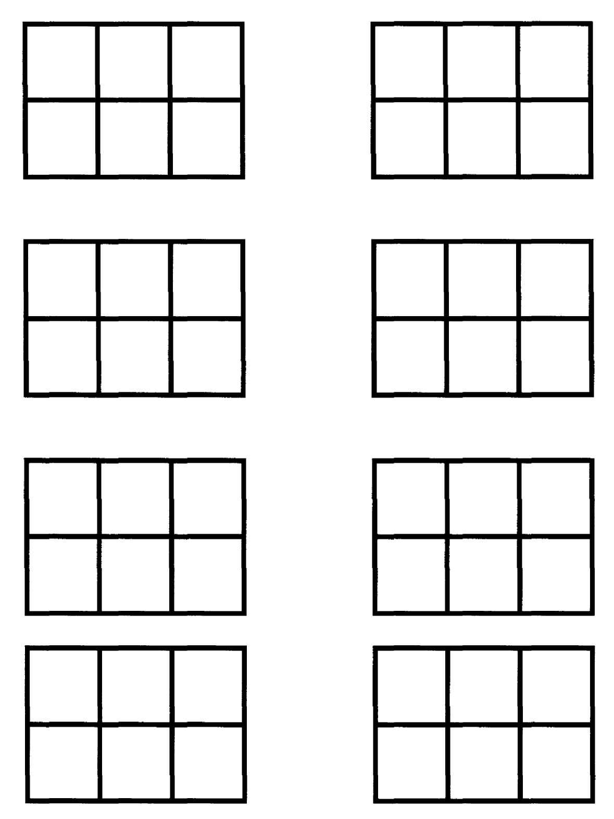

**Algebra Towers**

Another way to write expressions is by using an algebra tower. The two blocks below are added together to make the one above.



In the same way, complete the number towers below:









Now letters! Here is an algebraic

tower filled in for you:

Now try and complete this tower:



Try completing these algebra towers:

**Introduction:**

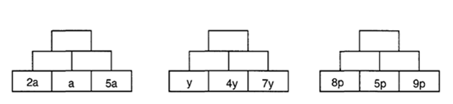

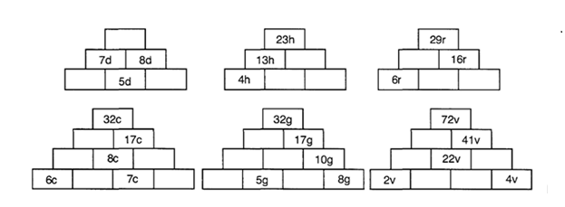**Consolidation: A bit trickier…**

**Extension: Can you complete these big towers?**

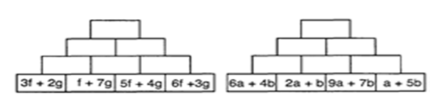

Sequences

**Part 1: Continue the sequence**

Write down the next 3 terms in each of the following sequences.

**Introduction: Consolidation:**

1. 2, 4, 6, 8, ……, ……, ……
2. 1, 3, 5, 7, ……, ……, ……
3. 3, 6, 9, 12, ……, ……, ……
4. 4, 8, 12, 16, ……, ……, ……
5. 1, 4, 7, 10, ……, ……, ……
6. 12, 23, 34, 45, ……, ……, ……
7. 100, 98, 96, 94, ……, ……, ……
8. 50, 44, 38, 32, ……, ……, ……
9. 63, 56, 49, 42, ……, ……, ……

10) 74, 63, 52, 41, ……, ……, ……

**Part 2: Harder Sequences**

These sequences do not go up by regular amounts. Find the next 3 terms in each one.

**Introduction: Consolidation:**

1. 2, 4, 8, 16, ……, ……, ……
2. 1, 3, 6, 10, ……, ……, ……
3. 1, 4, 9, 16, ……, ……, ……
4. 0, 5, 15, 30, ……, ……, ……
5. 3, 6, 12, 24, ……, ……, ……
6. 4, 8, 16, 32, ……, ……, ……
7. 25, 24, 22, 19, ……, ……, ……
8. 1, 0.5, 0.25, 0.125, ……, ……, ……
9. 1, 1, 2, 3, 5, 8, ……, ……, ……

10) 1, 10, 11, 21, 32, 53, ……, ……, ……

**Term to Term Rules**

**Part 1**

Use the term-to-term rule and 1st term to generate the first 5 terms of the following sequences:

1) 1st term: 1 Rule: add 3 ….…, ……., ……., ……., …….

2) 1st term: 5 Rule: multiply by 2 ….…, ……., ……., ……., …….

3) 1st term: 12 Rule: subtract 4 ….…, ……., ……., ……., …….

**Part 2**

For each sequence below state the first term and the rule. The first one has been done for you.

**Introduction:**

1) 2, 4, 6, 8, …… 1st Term: **2** Rule: **add 2**

2) 1, 3, 5, 7, …… 1st Term: ……… Rule: ………………………………………………

3) 3, 6, 9, 12, …… 1st Term: ……… Rule: ………………………………………………

4) 4, 8, 12, 16, …… 1st Term: ……… Rule: ………………………………………………

**Consolidation:**

5) 1, 4, 7, 10, …… 1st Term: ……… Rule: ………………………………………………

6) 12, 23, 34, 45, ……. 1st Term: ……… Rule: ………………………………………………

7) 100, 98, 96, 94, …… 1st Term: ……… Rule: ………………………………………………

8) 50, 44, 38, 32, …… 1st Term: ……… Rule: ………………………………………………

**Extension:**

9) 63, 56, 49, 42, …… 1st Term: ……… Rule: ………………………………………………

10) 74, 63, 52, 41, …… 1st Term: ……… Rule: ………………………………………………

**Part 3**

For each question below find at least two possible sequences by writing the next two terms and describe the rule used.

1. 1, 4, ………

The next two terms could be ……, …… Rule: ………………………………………………

OR

The next two terms could be ……, …… Rule: ………………………………………………

1. 3, 7, ………

The next two terms could be ……, …… Rule: ………………………………………………

OR

The next two terms could be ……, …… Rule: ………………………………………………

1. 5, 15, ………

The next two terms could be ……, …… Rule: ………………………………………………

OR

The next two terms could be ……, …… Rule: ………………………………………………

**Part 4**

For each question below find at least two possible sequences that could fit between each pair of numbers.

1. 1, …………………, 8

The sequence could be ………………………… Rule: ………………………………………………

OR

The sequence could be ………………………… Rule: ………………………………………………

1. 5, …………………, 15

The sequence could be ………………………… Rule: ………………………………………………

OR

The sequence could be ………………………… Rule: ………………………………………………

1. 4, …………………, 10

The sequence could be ………………………… Rule: ………………………………………………

OR

The sequence could be ………………………… Rule: ………………………………………………

Finding the nth Term from Patterns

For each of the patterns below:

a) Draw the next two patterns

b) Complete the table

c) Find the nth term

d) Find the 10th and 100th term

**Introduction:**

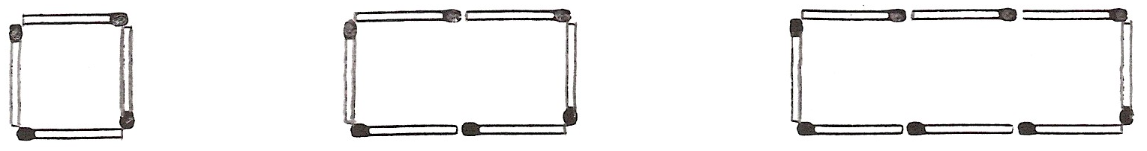 …………………….. ………………………

|  |  |  |  |  |  |
| --- | --- | --- | --- | --- | --- |
| Pattern Number | 1 | 2 | 3 | 4 | 5 |
| Number of match sticks |  |  |  |  |  |

nth term: ………… 10th value: ………… 100th value: …………

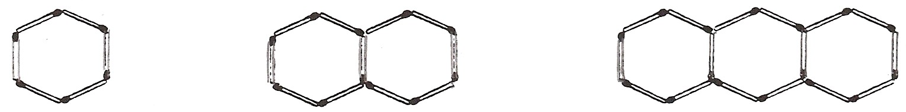 …………………….. ………………………

|  |  |  |  |  |  |
| --- | --- | --- | --- | --- | --- |
| Pattern Number | 1 | 2 | 3 | 4 | 5 |
| Number of match sticks |  |  |  |  |  |

nth term: ………… 10th value: ………… 100th value: …………

**Consolidation:**

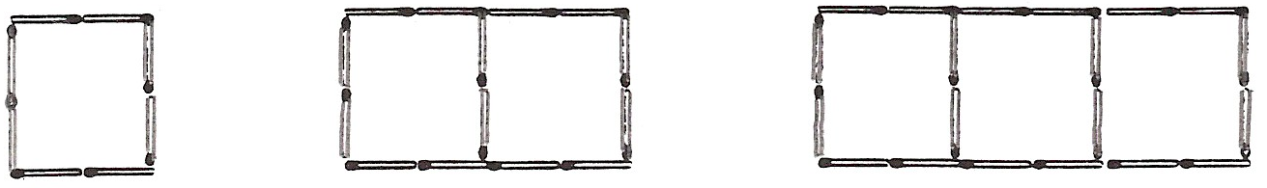 ……………………….. …………………………………

|  |  |  |  |  |  |
| --- | --- | --- | --- | --- | --- |
| Pattern Number | 1 | 2 | 3 | 4 | 5 |
| Number of match sticks |  |  |  |  |  |

nth term: ………… 10th value: ………… 100th value: …………

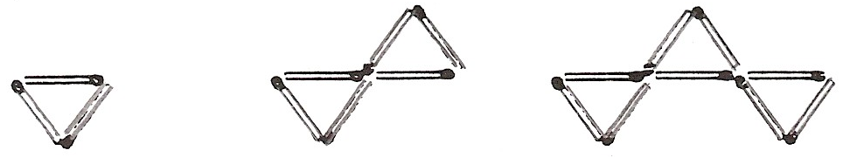 ……………………………… …………………………………

|  |  |  |  |  |  |
| --- | --- | --- | --- | --- | --- |
| Pattern Number | 1 | 2 | 3 | 4 | 5 |
| Number of match sticks |  |  |  |  |  |

nth term: ………… 10th value: ………… 100th value: …………

**Extension:**

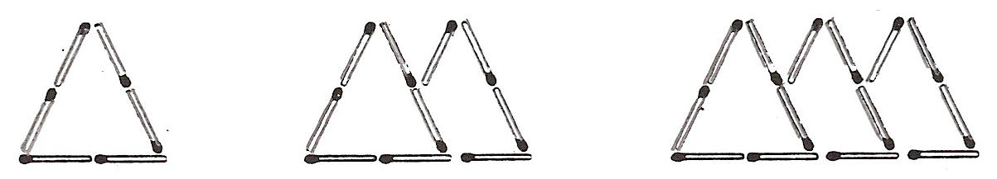 ………………………… ………………………………………………

|  |  |  |  |  |  |
| --- | --- | --- | --- | --- | --- |
| Pattern Number | 1 | 2 | 3 | 4 | 5 |
| Number of match sticks |  |  |  |  |  |

nth term: ………… 10th value: ………… 100th value: …………



…………………………………………………………… …………………………………………………..

|  |  |  |  |  |  |
| --- | --- | --- | --- | --- | --- |
| Pattern Number | 1 | 2 | 3 | 4 | 5 |
| Number of match sticks |  |  |  |  |  |

nth term: ………… 10th value: ………… 100th value: …………

**Investigation 1: Pascal's Triangle**

This picture shows the first five lines of Pascal’s triangle.

Can you work out how it is made?

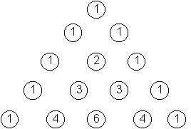

Each number is the total of the two numbers above it.

Work out the next five lines of Pascal’s triangle and write them below.

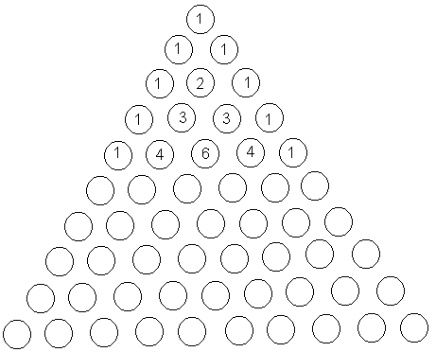

* Look at your diagram. What patterns can you see?
* Look at the odd and even numbers. How are they arranged in the triangle?
* Look at the diagonal lines on the triangle. What patterns do you notice?
* Is there a way of predicting the next line of the triangle, without having to work out each number by adding the two numbers above it?

**Extensions task:** Investigate the totals of the numbers in each horizontal row. Is there a pattern? Can you predict the next total?

Blank page for working out

**Investigation 1: Pascal's Triangle**

**Investigation 2: T-Shapes**

If you start putting numbers into a grid that is 9 columns wide then you get this layout:

|  |  |  |  |  |  |  |  |  |
| --- | --- | --- | --- | --- | --- | --- | --- | --- |
| 1 | 2 | 3 | 4 | 5 | 6 | 7 | 8 | 9 |
| 10 | 11 | 12 | 13 | 14 | 15 | 16 | 17 | 18 |
| 19 | 20 | 21 | 22 | 23 | 24 | 25 | 26 | 27 |
| 28 | 29 | 30 | 31 | 32 | 33 | 34 | 35 | 36 |
| 37 | 38 | 39 | … | … | … | … |  |  |
| … | … | … | … | … | … | … |  |  |

If you place a T shape on the numbers as shown above then we have:

|  |  |  |  |
| --- | --- | --- | --- |
| 11 | 12 | 13 |  |
|  | 21 |  |  |
|  | 30 |  |  |

Adding the five numbers gives an answer of 87.

**11 + 12 + 13 + 21 + 30 = 87**

Put the T shape on other positions on a grid with 9 columns and find the total when the numbers are added.

Consider how the position of the grid affects the total.

Can you create a general rule relating the position of the grid to the total?

Consider how you present your investigation; in particular consider the mathematical notation and the choice of any letters you use to represent numbers.

**Extension tasks:** What happens if I use a different grid size? What happens if I rotate the T? Does the size of the T matter?

**Investigation 2: T-Shapes**

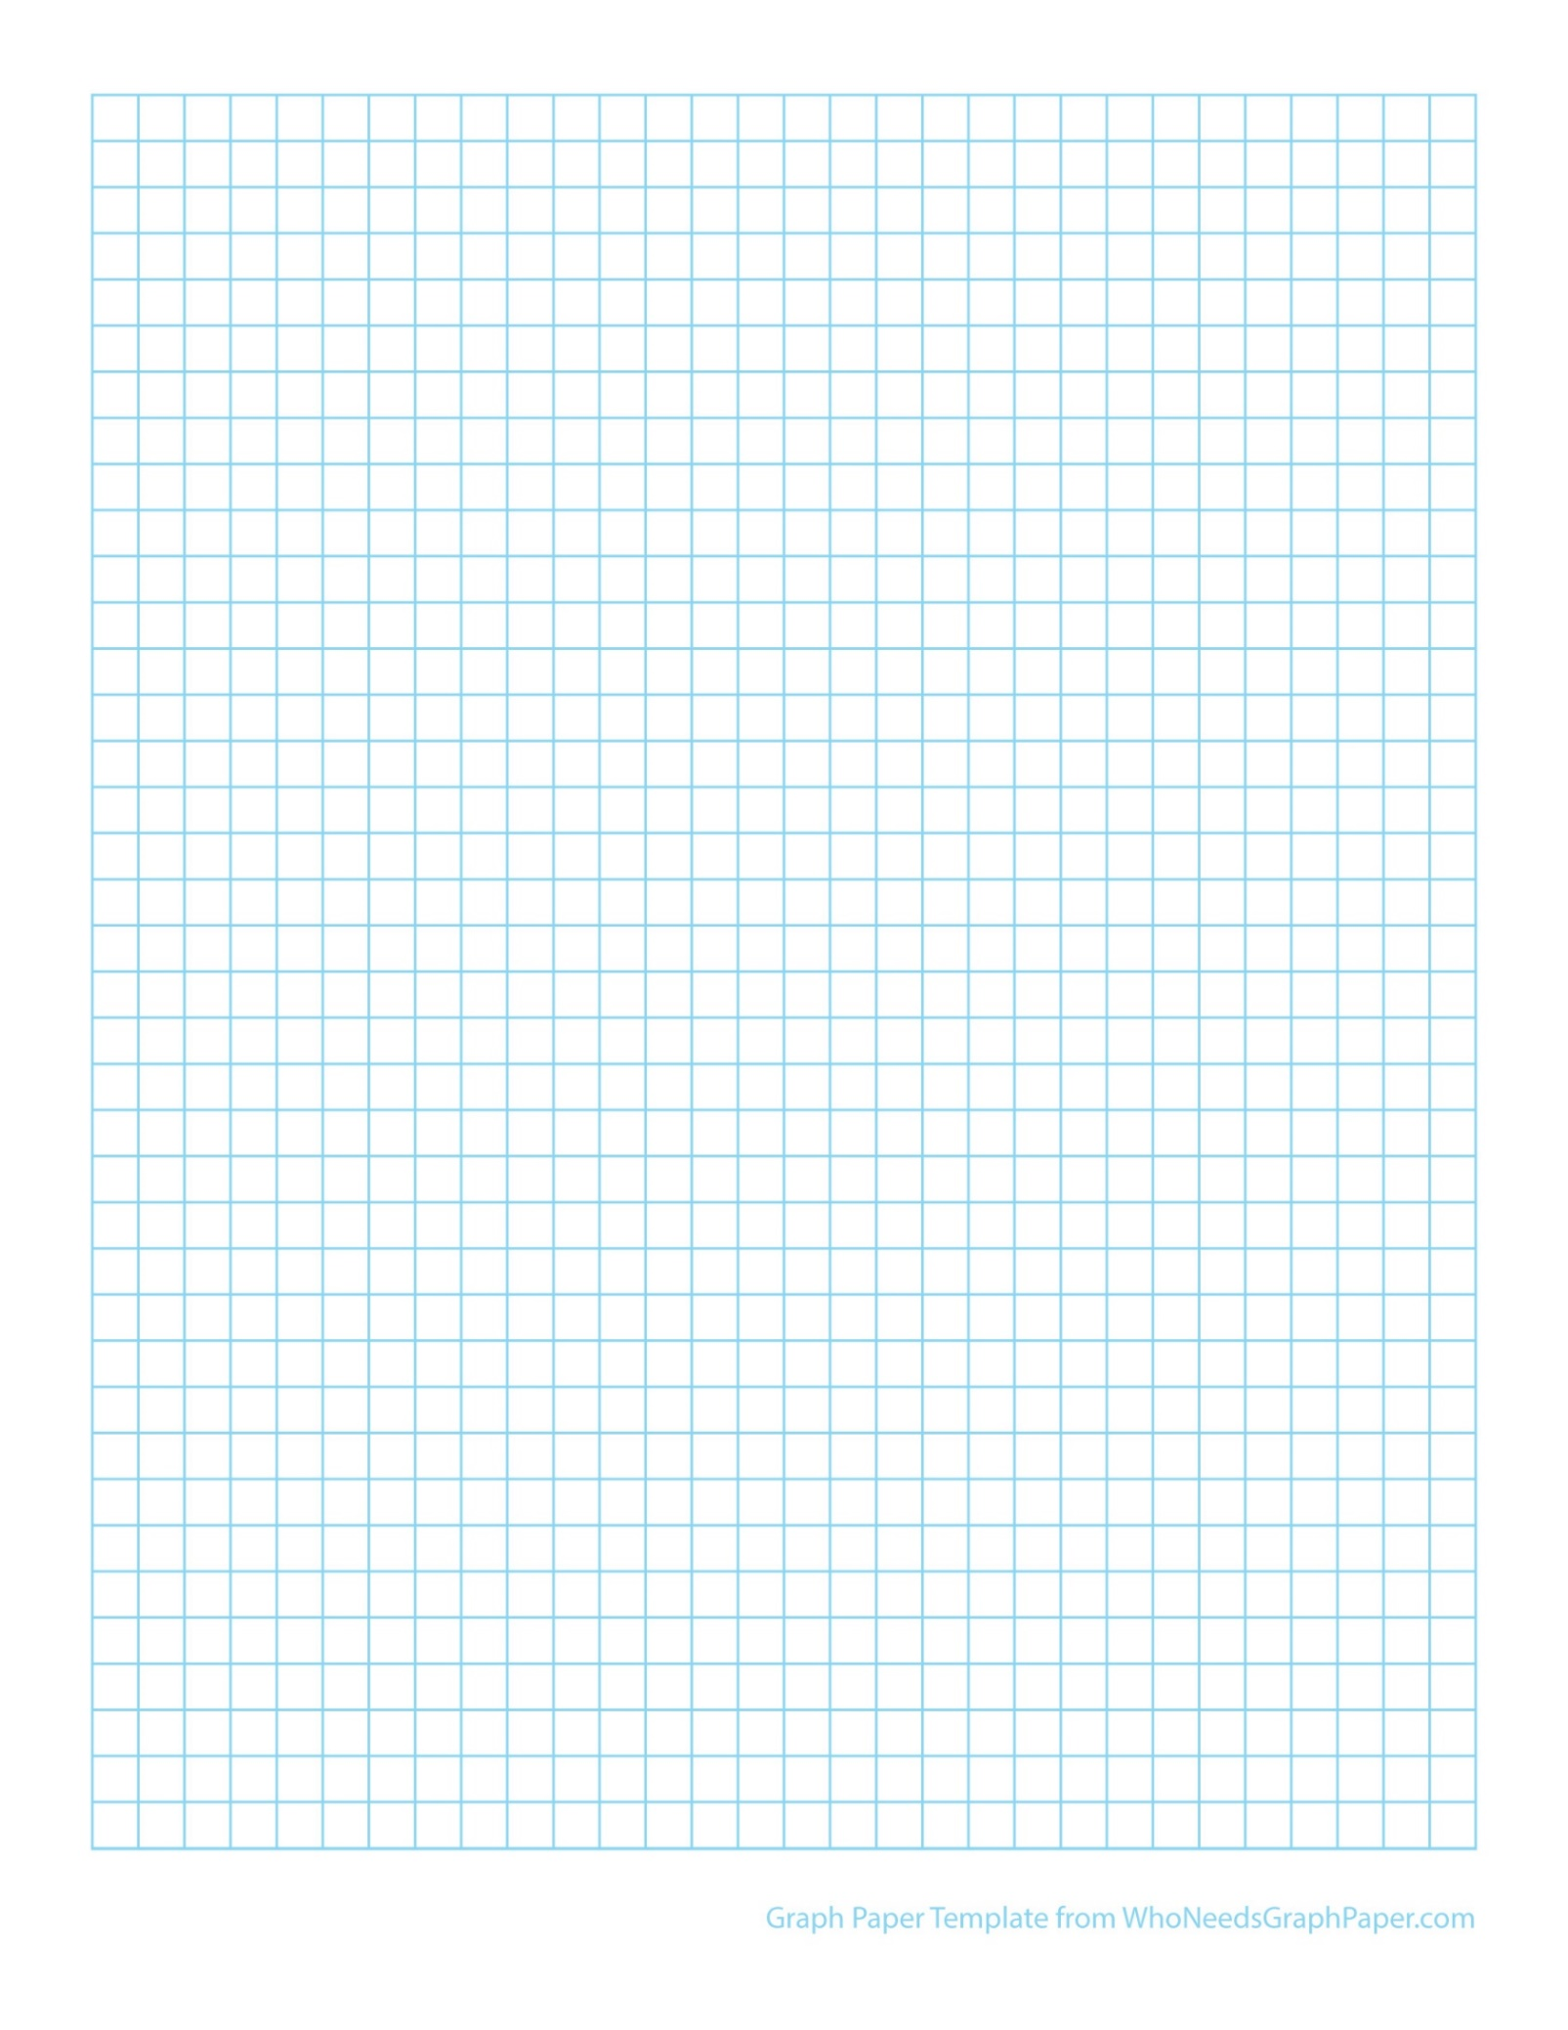

Blank page for working out

**Investigation 2: T-Shapes**

**Extra puzzling puzzles**

**Problem 1: Match Three**

**Can you complete the table below by identifying sets of 3 equivalent expressions?**

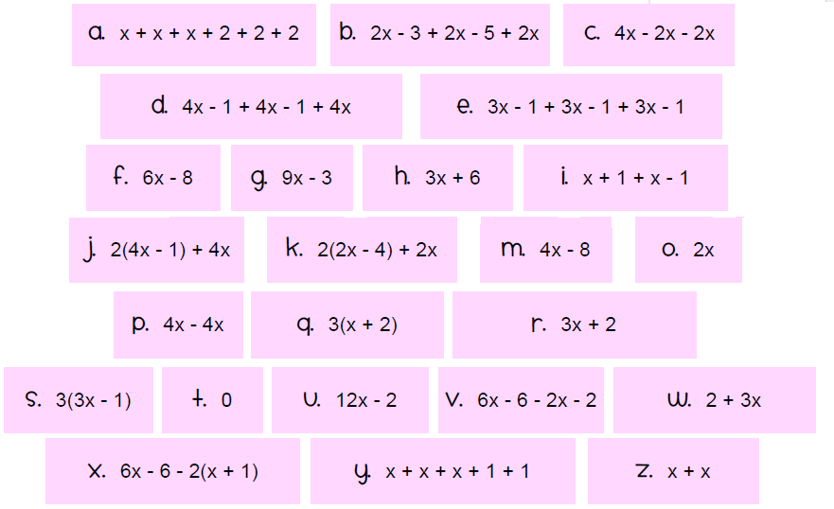

|  |  |  |  |  |  |  |  |
| --- | --- | --- | --- | --- | --- | --- | --- |
|  |  |  |  |  |  |  |  |
|  |  |  |  |  |  |  |  |
|  |  |  |  |  |  |  |  |

**Problem 2: If … Then…**

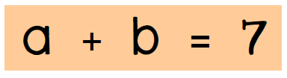

**If you know that…**

**What else can you calculate?**

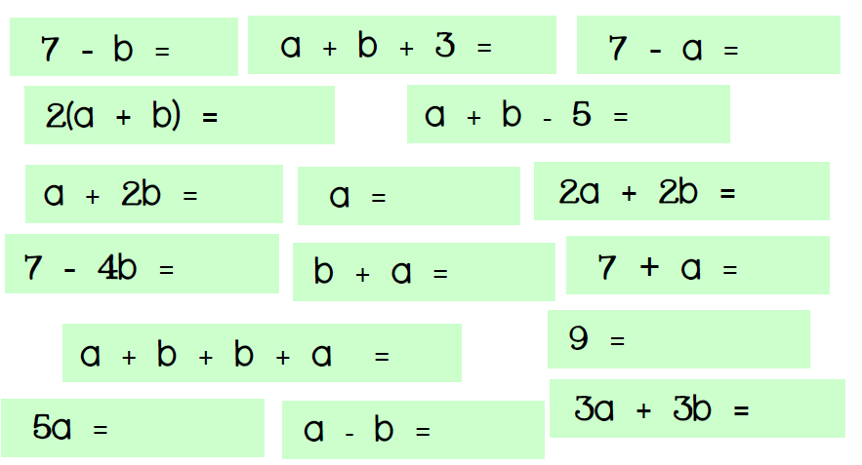

**Problem 3: Equations Cross Number**

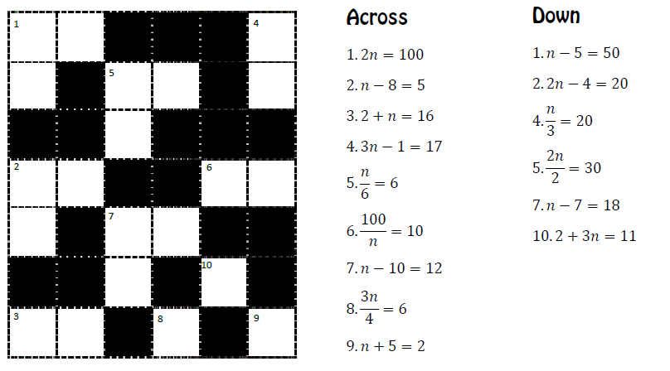

**Problem 4: Mystery Grid**

**Use the clues to complete the grid**

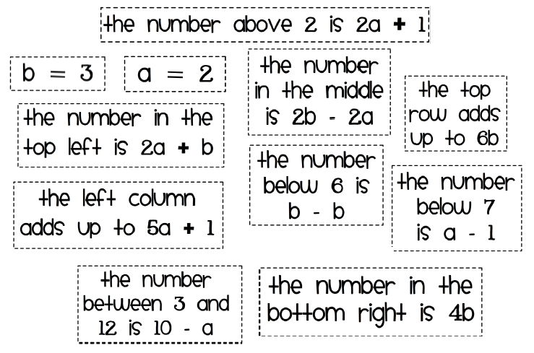

|  |  |  |
| --- | --- | --- |
|  |  |  |
|  |  |  |
|  |  |  |

**Problem 5: Number gaps**

**Can you fill in the missing numbers?**

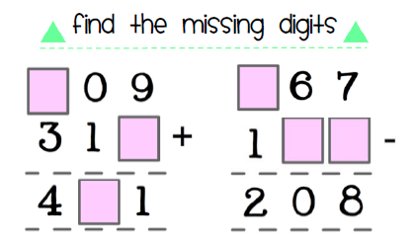

**Problem 6: Sequence match**

**Draw lines to match up the nth term with its 10th and 100th term…**

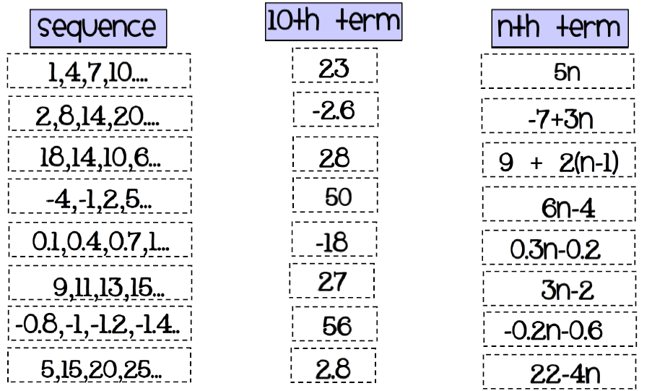

**Problem 7: Shape Substitution**

**Find the area and perimeter of the shapes below when x = 2**

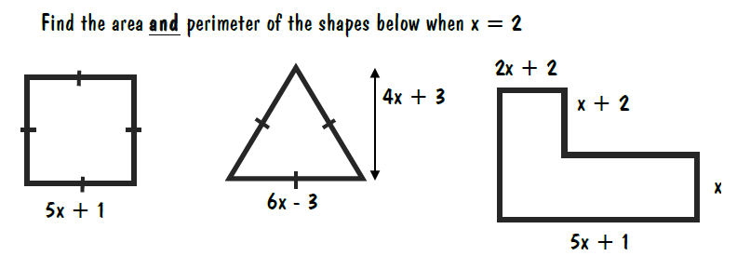

**Problem 8: Forming Equations**

**Can you match each statement to its equivalent equation and then find the solution too?**

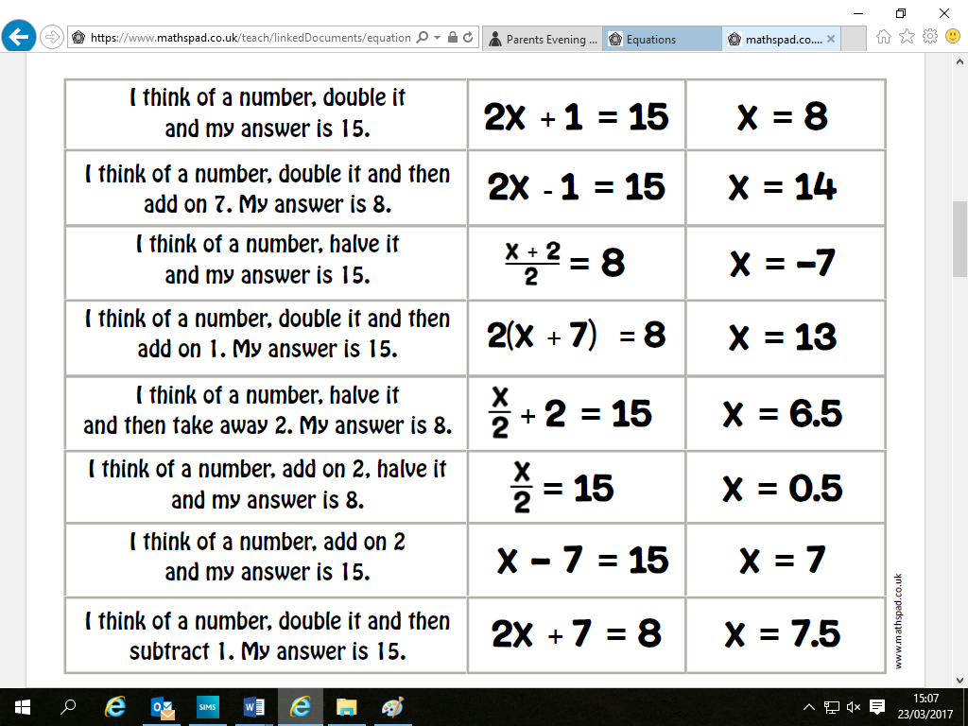

**My Mathematics Self Assessment**

This information will be very helpful to your new Year 7 Mathematics teacher.

Please be honest in your answers.

**Pupil Comments**

In mathematics I am good at:

……………………………………………………………………………………………………………………………….

……………………………………………………………………………………………………………………………….

……………………………………………………………………………………………………………………………….

My favourite topic is ……………………………………………………………………………

because ……………………………………………………………………………………………………………….

……………………………………………………………………………………………………………………………….

……………………………………………………………………………………………………………………………….

I would like to improve at:

……………………………………………………………………………………………………………………………….

……………………………………………………………………………………………………………………………….

……………………………………………………………………………………………………………………………….

In my Year 7 maths lessons I want to learn more about:

……………………………………………………………………………………………………………………………….

……………………………………………………………………………………………………………………………….

……………………………………………………………………………………………………………………………….

