Our intent:
With the average adult consuming media for almost 8 hours a day, we feel that Media Studies is a subject not only relevant, but essential, for many young people today. How someone responds to the media they consume will affect their ideas about people, places, society, politics, culture, themselves and their place in the world. We want to nurture students’ capacity to critically evaluate the media they consume and how it is shaping the world around them. GCSE Media Studies equips students with the knowledge and skills to do this as well as providing them an opportunity for creativity and autonomy when it comes to the media production they will research and create for coursework (NEA). For students who are interested in a future within the Media Industry, or work in social sciences, communications or public-facing roles, this subject is a great introduction to some of the experience and skills required for these career paths.
The Big Picture
From Eduqas:
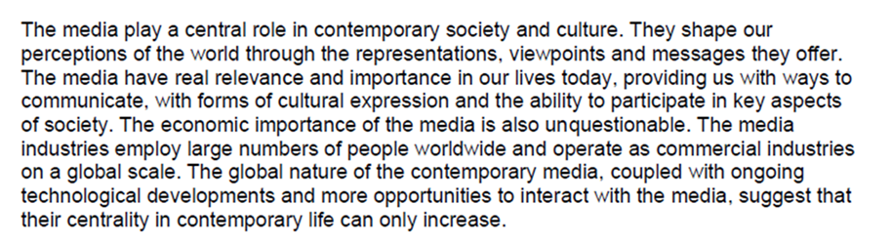
KS4
Students will study the GCSE Media Studies course offered by the exam board, Eduqas. All components will be studied in-depth and the final assessment outcomes are as follows:
- Exam 1 (40%) - Media Language, Representation, Industries and Audiences
- Exam 2 (30%) - in-depth study of two Media forms e.g. Television and Music
- Coursework (30%) - Media Production

 | Unit 1 | Unit 2 | Unit 3 | Unit 4 | Unit 5 | Unit 6
Year 10 | Introduction to Course.  Component 1 Section A: Advertising and Marketing | Component 1 Section B: Film Industry | Component 1 Section A: Magazines | Component 2 Section A: TV genre | Component 3: Media Production | Component 3: Media Production
Year 11 | Component 1 Section B: Video Games | Component 2 Section B: Music Videos and Online Media | Component 1 Section B: Radio Industry | Component 1 Section A: Newspapers | Revision | Revision

KS5
Any students opting for A Level Media Studies will enjoy a more complex interrogation of the role of the media in our modern lives, studying historical and contemporary products from print, audio-visual and online media as well as gaining an understanding of how the production process and industry behind the media we consume functions.
GCSE Media Studies specification: Eduqas - C680QS
A Level Media Studies specification: Eduqas - A680QS

