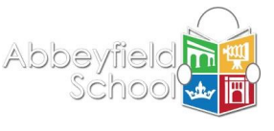

Literacy for Learning

Supporting at home

***Suggestions for how you can support the development of your child’s literacy skills further at home.***

**Reading at Home**

Even after they begin secondary school, students should be reading for a minimum of 20 minutes a day. This could be reading a book, eBook, magazine, newspaper, online articles or listening to audiobook or podcast (for Year 7 to 9).

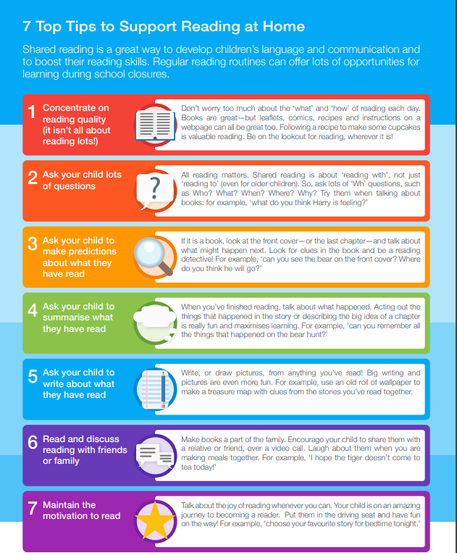

**Additional tips to support your child with their reading**:

* Let your child choose what to read, rather than selecting what you think they should read.
* Encourage your child to read magazines, comics, newspapers, and the internet as well as books.
* Listening to a podcast or audiobook also counts as reading.
* Talk to your child about books or magazines you haven’t enjoyed, as well as those you love.
* Don’t forget TV tie-ins and books about interests such as computer games, sports or music bands can engage your child.
* Remember that your child is reading when they are looking at bus timetables, menus, instructions, TV guides, cook books, the internet etc…
* Help your child find books they will enjoy by joining the public library if you are not already members. It is free to join. You can find out about the services that Wiltshire Libraries offer to children and teens in the following link: <https://www.wiltshire.gov.uk/article/1327/Services-for-children-and-teens>
* Try some skimming and scanning together. Skimming is reading through a piece of text quickly to find out the main idea; scanning is glancing through a piece of text to find specific information. You can do this with a newspaper – perhaps ask your child to find something out for you. Why not ask them to scan a newspaper for news about a favourite footballer, find out the weekend weather, or skim-read a recipe to tell you the basic steps?
* Help your child work out what an unfamiliar word means by getting them to read the rest of the sentence and look for clues.
* Assist by testing your child when they have spellings to learn, and encourage them to look up words they don’t know in a dictionary.
* Build up your child's vocabulary. As they go through secondary school, your child will need to know specialist words and recognise them when they are reading. To help them learn these words, you could ask your child to explain their meanings to you.

**Reading Resources at Abbeyfield**

At Abbeyfield School we have a number of reading resources to support your child with developing their reading:

**Issues Online**

Issues Online provides parents and children with a safe, reliable place to explore today’s most important social issues. It contains hundreds of articles, infographics, videos, assignment ideas, and eBooks on topics ranging from human rights to economics, religion, and more. Parents and children can access Issues Online using the following link: <https://sites.google.com/view/abbeyfieldlrc/issues-online>

**Reading Lists**

Our school librarian, Mr. Evans, has created a reading list page on the school Learning Resources Centre website. It contains nearly 100 reading lists covering various non-fiction book topics and fiction genre themes. For all the books featured in the reading lists, there is a copy available in our school Learning Resources Centre. You can access the reading list page using the following link: <https://sites.google.com/view/abbeyfieldlrc/reading-lists>

**ReadPlus**

ReadPlus is an online reading recommendation search database designed to help your child find their next read. Each book record contains a brief blurb about the book and website links to author profiles and reviews for certain books. You can access ReadPlus using the following link: <https://sites.google.com/view/abbeyfieldlrc/readplus>

**Sora**

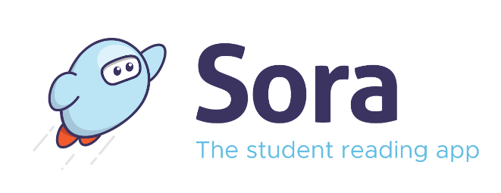Sora is a new interactive online library that your child can access via their internet browser on a laptop or computer, or by downloading the Sora App from the Google or Apple App Store. Students can log in to Sora using their school email address and password. They can borrow up to 5 items (eBooks, digital audiobooks, and digital magazines) for 14 days free of charge. For additional information about Sora, you can access the Sora information page using the following link: <https://sites.google.com/view/abbeyfieldlrc/sora>

For any additional tips or advice on supporting your child's reading, you can access the Parents and Guardians Reading Advice and Resource page on the Learning Resources Centre website: <https://sites.google.com/view/abbeyfieldlrc/parents-and-guardians-reading-advice-and-resources>, contact Mr. Evans (School Librarian) by email at library@abbeyfield.wilts.sch.uk, or email your child's English teacher.

**Developing Vocabulary at Home**

Each lesson students have new key words identified and discussed to support vocabulary development. Student are encouraged to investigate this new key language so talk to you children about the new vocabulary and encourage them to investigate further.

How to talk about words….

|  |  |
| --- | --- |
| **Prefix** - A letter or letters placed at the start of a word to change its meaning. E.g. in ‘unfair’ the prefix is ‘un’ meaning ‘the opposite of’ | **Suffix** - A letter or letters placed at the end of a word to change its meaning. E.g. in ‘beautiful’, ‘ful’ is the suffix, meaning ‘full of’. |
| **Etymology** - The history of words and how their meanings change over time. | **Morphology** - How words are formed and how they relate to other words. |
| **Synonym** - A word which has the same or almost the same meaning as another. E.g. ‘light’ and ‘bright | **Antonym** - A word which has the opposite meaning as another. E.g. ‘bad’ and ‘good’. |
| **Root** - The original form of the word without any suffixes or prefixes attached. E.g. ‘beautiful’ has the root ‘beauty’. |  |

**Possible discussion questions:**

Where did you use the new key word?

What does it mean?

Can it have more than one meaning?

Can you think of any synonyms or antonyms?

How might you use this word in school?

Can it be used in any other subjects other than the one you learnt it in today?

**Bedrock Learning**

As a school, we use Bedrock Learning, which is a literacy curriculum learning program. All Key Stage 3 students are encouraged to complete 2-4 elements each week (1 element = a pre/post topic test or lesson) on the vocabulary or grammar part of the program as part of their English homework. Each element takes 15 to 20 minutes to complete. During each lesson, your child will develop their vocabulary and grammar skills through compelling fiction and non-fiction texts and receive instant feedback on their progress.

Bedrock is self-marking and adapts to each learner, making it easy for your child to use independently and share with you at home. As a parent, you can track their progress, see what words and grammar skills they are learning, and give them more opportunities to use these words in conversations or review the grammar skills they have been learning when proofreading a piece of homework with them.

Bedrock Learning is also an adaptive learning program, so your child is always being tested on prior vocabulary words and grammar skills and receives refreshers on vocabulary words and grammar skills they still need to master. Students can monitor their progress of different vocabulary words and grammar skills with the program's knowledge organiser feature.

For more information about the program and access to additional Bedrock Learning activity booklets to support your child's literacy, please head over to our Bedrock Learning Help Zone area on the Learning Resources Centre website: <https://sites.google.com/view/abbeyfieldlrc/bedrock-learning-help-zone>

If you would like a Bedrock Learning Parent/Guardian account to monitor your child's progress on the program, please email Mr. Evans, our school librarian, at library@abbeyfield.wilts.sch.uk

**Literacy Competitions**

Throughout the school year, there is a wide range of reading and other literacy competitions that take place. Encourage your child to participate in some of these – you can even participate yourself. Why not get your child involved in our 'Abbeyfield Reading House Competition' challenge? Or, if your child is a budding author, encourage them to take part in the 'Bedrock Young Authors' competition.

Competitions take place throughout the year, so head to the school Learning Resources Centre website: <https://sites.google.com/view/abbeyfieldlrc/home> Students can check out the "English What's On" noticeboard. Parents/guardians can look out for updates on the school social media channels and in the school newsletter.

