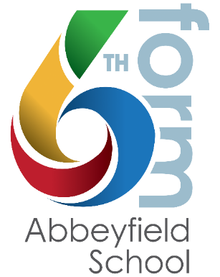PERSONAL STATEMENT BOOKLET

Name: …………………………………….

|  |
| --- |
|  |

This is required for university applications, and as a basis for any apprenticeship or job applications so needs to be completed by ALL students. (replace ‘course’ for ‘job’ if non-university).

**Deadline: Monday 21st July 2025 (printed copy).**

**GUIDANCE:**

Personal statements are basically you explaining why the university should offer you a place on their course (or an employer offer you a position). It is an opportunity to showcase your passion and research, and explain why you want to study this course, or work for this company / job role.

You need to write confidently, concisely and accurately. NO spelling or punctuation mistakes so please ask someone to proof read before you submit.

* 4,000 characters including spaces (this cannot be exceeded).
* Minimum 350 characters per section.

**IMPORTANT: The use of AI**

Your personal statement must be your own work, and universities and employers will screen these to check and will not process applications from students deemed to have ‘cheated’. For this reason, you will have to verify that your PS hasn’t been copied or provided by another source including AI software. We will also check in school, and will not submit your application if we feel that your personal statement is not your own work.

However, UCAS do recognise the value of AI in supporting, as outlined below:

1. To brainstorm some ideas about topics that are relevant to your chosen subject / job role and which you can then relate to your own personal experiences and opinions, and to list skills that are relevant to the course you are applying for to allow you to think about how your talents align.
2. Support with structuring your personal statement (although UCAS ‘personal statement builder’ may be more helpful – see link below).
3. To check readability. ChatGTP, or similar, may suggest ways to rephrase sentences or make them more concise whilst still maintaining their meaning.

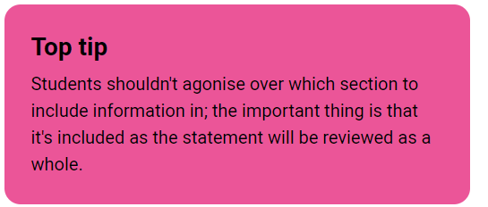**TIPS:**

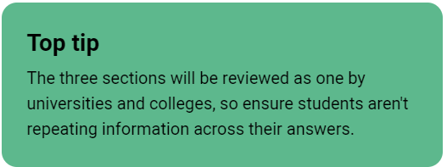

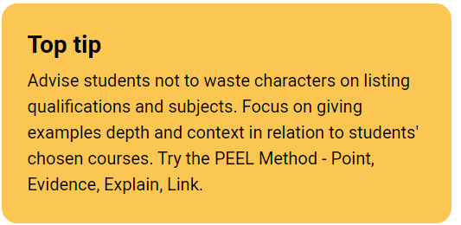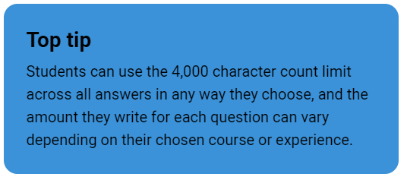

**RESOURCES:**

1. **UCAS personal statement building support**

<https://www.ucas.com/applying/applying-to-university/writing-personal-statement/personal-statement-builder?check_logged_in=1>

1. **UCAS 2026 personal statement guides**

These provide some guidance for subject areas. <https://www.ucas.com/applying/applying-university/writing-your-personal-statement/2026-personal-statement-guides>

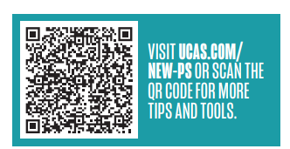

**------------------------------------------------------------------------------------------------**

**PLANNING: (your final draft will be electronic)**

|  |
| --- |
| Why do you want to study this course/ apply for this job?  *Show your passion and knowledge for your chosen subject. It lets universities and colleges and employers know why you’re a good fit.* |
| How have your qualifications and studies helped you to prepare for this course or job role?  *Talk about the skills you’ve developed in your education, and how they’ll help you succeed.* |
| What else have you done to prepare outside of education, and why are these experiences useful?  *Reflect on any other activities or personal experiences outside the classroom that make you suited to the course or job role.* |

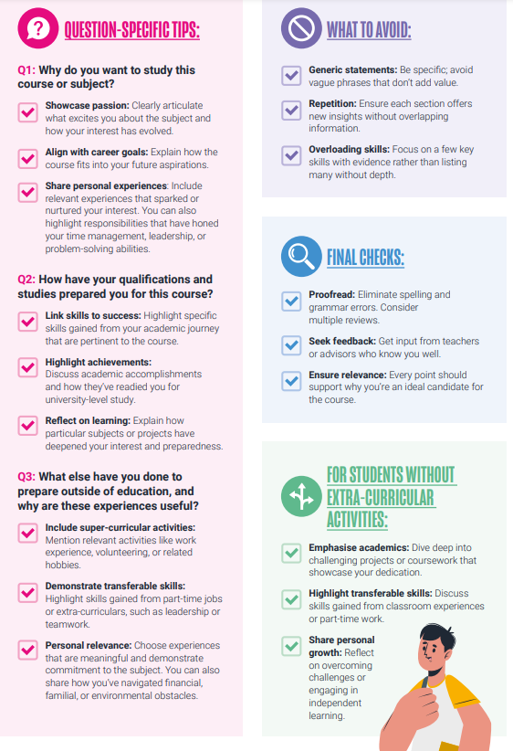**CHECKLIST:**